The hAPI: A DEVELOPER’S GUIDE

Documentation and Guided Examples

A guide to developing haptic simulations with two open-source haptic technologies: The Hapkit and Haply Development Kit.

Written and Compiled By Colin Gallacher and Steven Ding with contributions from Melisa Orta, Oliver Schneider, Allison Okamura, and Karon MacLean

The hAPI has been initially developed for use in the World Haptics Conference 2017 Student Innovation Challenge. The challenge organizers are Oliver Schneider, Melisa Orta, Colin Gallacher, Allison Okamura, and Karon MacLean. The goal of this Developer’s Guide is to instruct you on the setup and programming of two open-source haptic platforms the Hapkit and the Haply Development Kit (HDK). The objective is to provide haptics students and enthusiasts a more accessible and transparent way to develop force feedback haptic simulations.

Good luck!





***\*\*Tip: This document is intended to be viewed online. Make sure View/Print Layout is unchecked in the menu to avoid unwanted page breaks.***

*Copyright (C) 2017 Colin Gallacher. Permission is granted to copy, distribute and/or modify this document under the terms of the GNU Free Documentation License, Version 1.3 or any later version published by the Free Software Foundation; with no Invariant Sections, no Front-Cover Texts, and no Back-Cover Texts. A copy of the license is included in the section entitled "GNU Free Documentation License".*

## HAPI SYSTEM INTRODUCTION

With the proliferation of rapid-prototyping tools and open-source development platforms, it is now possible for makers, researchers, and hobbyists to develop their own haptic systems. With the Haptic API (hAPI), it is our attempt to unify prior work that has been done to develop low-cost and accessible haptic systems aimed at lowering the barrier of entry into the field.

The hAPI is an open-sourced haptics application programing interface (API) that is intended to make prototyping and developing haptic simulations more accessible than it has been before. A major objective for the hAPI is that it allow users to develop and prototype across a number of devices and easily add their own designs to get their simulations up and running quickly. Specifically, its purpose is to provide a platform with which users can become exposed to the basic concepts of a kinesthetic (force-feedback) haptic system. With this platform, we hope you can quickly develop haptic applications using open-source haptic devices such as Hapkit and Haply.

In this document, we have documented the hAPI in the context of two open-sourced hardware systems that it has been designed to work with - specifically, the “getting started” stage.

See also hAPI Documentation and Examples for instructions on how to use the hAPI in your haptic simulation development.

**DISCLAIMER**

The following documentation is a work in progress and may possess errors. If any errors are found, please contact Colin at [cr.gallac@gmail.com](mailto:cr.gallac@gmail.com) and I’ll be sure to correct the mistake! Thanks!

TABLE OF CONTENTS

HAPI INTRODUCTION

1. The Haptic System and the hAPI

1.1. THE HAPTIC SYSTEM

1.2. DEVELOPING WITH THE HAPLY DEV BOARD AND HAPKIT

1.2.1. THE HAPKIT

1.2.2. THE HAPLY DEV BOARD

1.3. HAPI ARCHITECTURE

1.3.1. SUMMARY

2. GUIDED EXAMPLES

2.1. HAPKIT SIMULATION WORKFLOW

2.2. Hapkit

2.2.1. First Contact

2.2.2. arduino control loop

2.2.3. Processing setup

2.2.4. Hello Wall

2.2.5. arduino control loop

2.2.6. Processing setup

2.2.7. Processing draw

2.2.8. Processing animations

2.3. HAPLY SIMULATION WORKFLOW

2.4. Haply Dev Board

2.4.1. Hello Wall

2.4.2. System Setup

2.4.3. Animation Event

2.4.4. Haptic Simulation Event

2.4.5. Hello Ball

2.4.6. System Setup

2.4.7. Animation Event

2.4.8. Haptic Simulation Event

2.4.9. Gravity

2.4.10. System Setup

2.4.11. Animation Event

2.4.12. Haptic Simulation Event

3. HAPI DOCUMENTATION

3.0.1. HAPI UML

3.1. BOARD CLASS

3.1.1. Constructor Detail

3.1.2. Method Detail

3.2. DEVICE CLASS

3.2.1. Constructor Detail

3.2.2. Method Detail

3.3. SENSOR CLASS

3.3.1. Constructor Detail

3.3.2. Method Detail

3.4. ACTUATOR CLASS

3.4.1. Constructor Detail

3.4.2. Method Detail

3.5. MECHANISMS CLASS

3.5.1. Constructor Detail

3.5.2. Method Detail

4. Appendix

4.1. Converting between screen size and SI units

4.2. Basic Contact Rendering in 2D: To Come...

# 1. Haptic Systems and the hAPI

## 1.1. HAPTIC SYSTEMS

Haptics is the technology of simulating the sensation of touch with computers and electronic devices. Force-feedback haptics is concerned with simulating forces, typically at specific points of interaction with a held manipulandum. Control boards for open-source haptic devices, such as the Hapkit Board and Haply Development Board, are designed to make creating force feedback cheap and easy.

Since computers don’t come with the built in functionality to control actuators and read sensors, we use a control board to handle these tasks. The electronics on the control board can vary greatly, but typically handle the sensing, actuation, signal processing, and signal amplification. The control board realizes the synthesis between mechanics and electronics. Recently, the ability to produce cheap and powerful control boards has become a reality. Typically these control boards, or microcontrollers, are less powerful than a computer but are geared towards a specific task like the sensing and actuation described before.

The desktop and laptop computers that we have today are much more versatile and are typically much more powerful, easily handling complex calculations and demanding graphics rendering. In order to build multimodal simulations with touch, audio, and visual capabilities we can take advantage of both the control boards as well as the computer. Depending on the microcontroller’s capabilities, we are able to divvy up the vital aspects of the haptic simulation across the computer and the control board.

This is where the hAPI comes in; it allows us to use the familiar computer interface to simplify handling many of the more annoying details of a haptic simulation (i.e. the bits and bytes of communication protocols, specifics about what sensors/actuators are being used, etc.). The hAPI functions as an intermediary link between the controller and the device.

## 1.2. SOFTWARE ARCHITECTURE FOR THE HAPKIT AND HAPLY DEV BOARD//// PROGRAM LAYOUT HAPKIT AND HAPLY DEV BOARD

The Hapkit and Haply devices have different firmware architectures - i.e., the division of operational code between client and server . There are differences between how the Hapkit and the Haply Dev Board divvy up the components of the simulation environment.

### 1.2.1. THE HAPKIT

The Hapkit board functions by placing most of the simulated environment on the control board. This is done due to limitations imposed by the serial-to-usb converter that handles the communication between the microcontroller and the computer, but it also allows the Hapkit to run haptic simulations even when it is not connected to the computer. The serial-to-usb converter restricts the communication speeds to around 200 Hz. These rates are too slow to simulate really rigid contacts and have them feel smooth. However, these rates are fast enough for us to visualize the simulation on the computer screen. So, we program the virtual environment on the control board, using the Arduino Development Environment, and then communicate back important data from the device like the states and forces to be rendered graphically on the computer.

The following figure displays how the Hapkit haptic system is divided between the computer and the Hapkit control board.

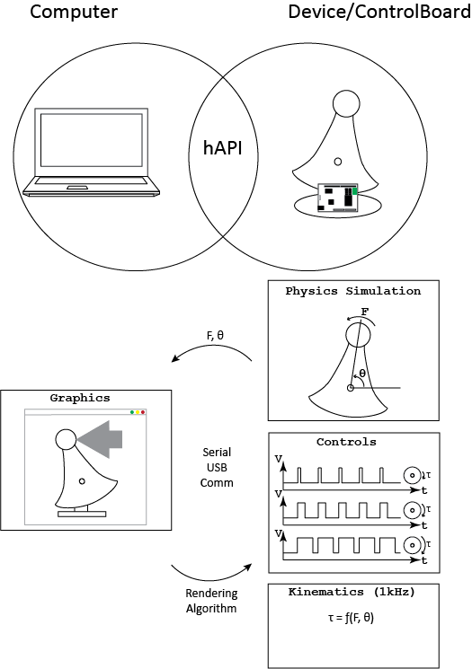

You can see that the Hapkit contains an ecosystem where the simulation physics, device kinematics, and device controls are all updated on board. The hAPI handles the communication between the board and the graphics, allowing us to depict on screen what is being simulated on the board. The computer does not actually simulate any of the contact physics being rendered on the device but can send parameters to the device, instructing the Hapkit to render different physical environments, or to change parameters within the environment being rendered. The physics simulation, device kinematics, and device controls are all updated at 1 kHz on board the Hapkit.

The computer controls the rate of communication between the board and the computer. It will send data to the device at a frequency, set by the user on the computer side, between 40-60 Hz. When the Hapkit receives a data packet it will respond to the packet with data specified by the user. This is that data that is used to update the graphical environment.

|  |
| --- |
| *Note:*  *While the world appears to move around us very smoothly, in reality we process what we see, hear, and feel at different rates. For example, our computers and TVs only update the image on screen around 50-60 times a second (aka 50-60Hz). In our haptic simulations, we only need to update the graphics component between 30-60 times per second. This allows us to save valuable processing power to, instead, calculate the physics simulation of the system.*  *Why not just run the physics simulation at the 30-60 Hz like the graphics? Human haptic sensing is highly sensitive to high-frequency vibrations, and frames updating at 30-60 Hz would be noticeably choppy. So we make the physics and haptic parts of our simulations update at 1000 times per second to make the forces feel ‘smooth’. In addition, the simulation of physical interaction coupled with the dynamics of a physical device typically requires fast simulation rates to remain stable.* |

### 1.2.2. THE HAPLY DEV BOARD

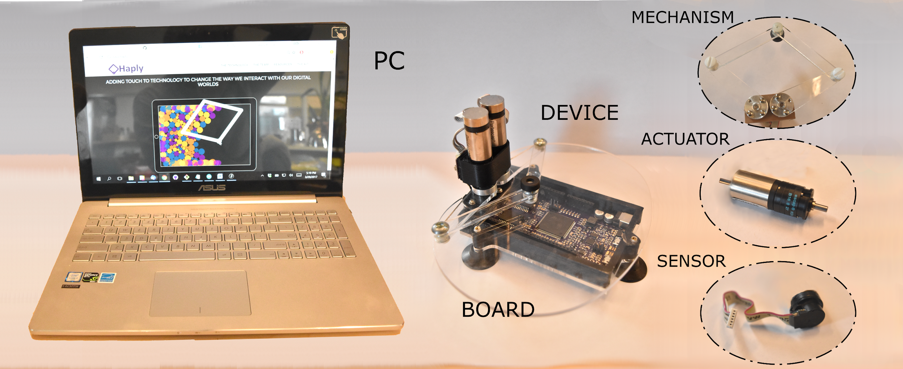

To develop with the Haply Dev Board, user's program all the details of the simulation on the computer. The physics simulation, graphics, audio, device kinematics, and force calculations are all performed on the powerful computer processors. We only use the hAPI to read the device states and send the values of the desired forces to the device to command the actuators.

You can see in the figure below how the Haply haptic system is divided between the Haply Dev board and the user's computer.

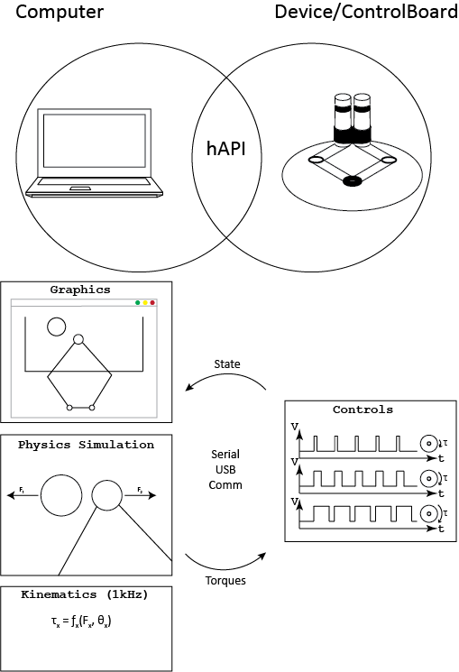

The Haply Dev Board handles the simulation entirely on board the computer. This means that instead of just handling the graphics we must also handle the physics and kinematics within the computer environment. We operate under the assumptions that we want the physics simulation and kinematics to run much faster than the graphics simulation because we want to ensure that all the states are updated fast enough that the haptic feedback can be sent to the device and rendered in time to feel smooth to the user. Additionally, have to update the graphics, albeit at a much slower rate, in order for them to be viewed as a continuous environment to the user. To accomplish this we time the program and call the simulation function at a rate of 1kHz and the graphics function at a rate of 40-60Hz. This is actually very similar to the Hapkit, as seen above, except the physics simulation and kinematics are run on board the Hapkit board at a rate of 1kHz instead of the computer.

Finally, it is important the we send the data from the computer to the device.Since the speed of communication must be pretty fast to sense a smooth and stable simulation, it’s vital that the duration of time from when we receive data from the control board, update our simulation calculations, and send back the forces, is done in around a millisecond (1kHz). This isn’t a problem, however, since because the Haply Dev Board only handles the device controls, we run the controls at a rate of 20kHz. This allows us to update the device controls, when set by the computer, and then subsequently return back the necessary data all in one time-step as seen by the physics simulation onboard the computer.

This means the Haply Dev Board is able to handle communication rates at sufficiently high speeds for haptic simulation. However, rendering really complex simulations that require a high number of calculations and complex graphic rendering can lead to the simulation slowing down to several milliseconds which can lead to unwanted effects like feeling ‘choppy’.

## 1.3. HAPI ARCHITECTURE

The previous section dealt with some of the intricacies of two open-source haptic systems and the way in which the simulation modalities are divided between the computer and the control board. However, you may have noticed that what is common between the two haptic systems was the use of the hAPI to handle the communication between our computers and control boards. The hAPI has been developed to function as a modular haptics API, allowing users to mix and match various types of robotic mechanisms, sensors, and actuators to prototype different types of haptic devices.

The hAPI design can be interpreted as a branching tree. At the foundation of the tree is the ***Board*.** A **Board** functions as the connection between the computer and the **Device.** The **Device** is the physical interface that the user manipulates when interacting with a virtual environment. Several **Devices** can be connected and controlled by a single **Board.** A **Device** is composed of several crucial components that are essential in a haptic system. The **Device** is physically composed of several joints and links that make up the physical **Mechanism** of the **Device.** These **Mechanisms** impact the way forces and torques are transmitted to the user as well as what positions can be reached. However, in order for a **Mechanism** to function we must have **Sensors** and **Actuators** that detect how the **Device** is positioned and can generate torques to move the **Device.** The **Mechanism, Sensors, and Actuators** make up the key components to any **Device.** We can combine them in a number of ways to make many versatile devices.

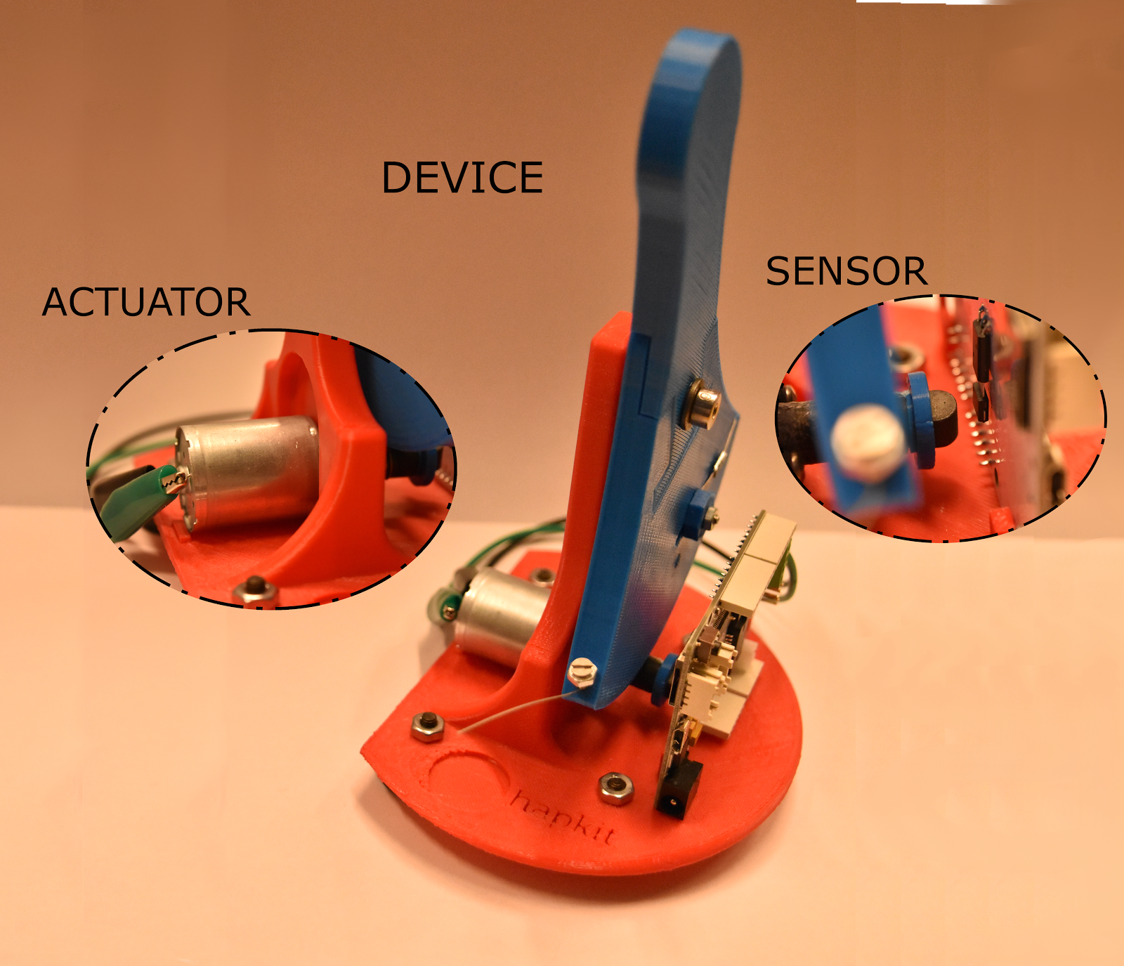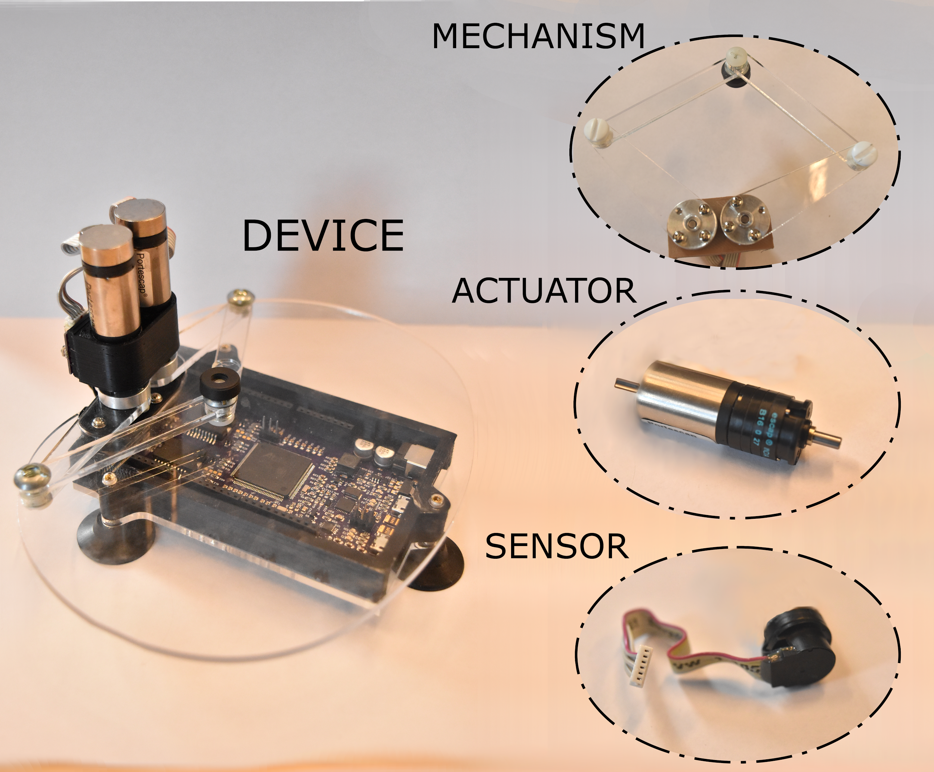

The physical understanding of how we can compose **Devices** from different **Mechanisms, Sensors,** and **Actuators** leads, naturally ,to the way the hAPI is partitioned using classes of the same name. In the same way we have a physical **Board**, we have a class representation of the **Board**. It can be populated by a number of **Device** objects which are, themselves, comprised of a number of **Sensor, Actuator,** and **Mechanism** objects.

At their most basic level, each class handles a different layer of the haptic simulation. At the most granular level, **Sensors,** like encoders, keep track of the angles through which a joint link rotates; **Actuators**, such as motors, control the transmission of torques that drive the robotic arms; **Mechanisms** contain kinematic parameters that allow us to convert between angles to positions and torques to forces; **Devices** conglomerate the subcomponents and connect them in meaningful ways, passing information from the subcomponents to the board to be used in simulation and receiving information about what forces to render; and, finally, **Boards** control the data transmission between the Computer and the device.

The following figures demonstrate the hAPI hierarchical structure for both the Hapkit as well as the Haply Dev Board and Haply 2DoF device.

Hapkit hAPI Structure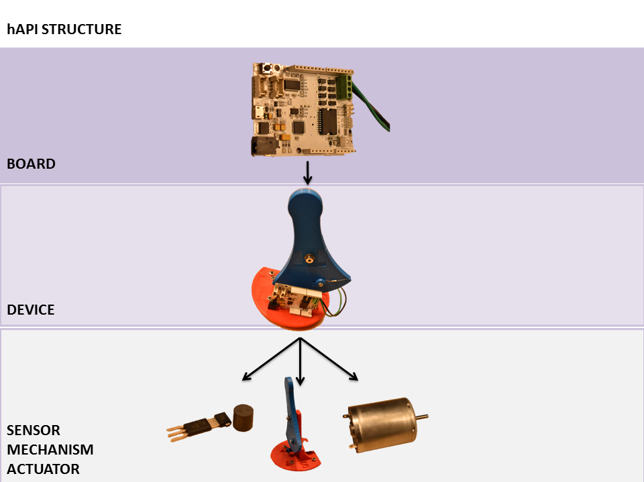

The Hapkit is a single degree-of-freedom device (1 DoF) which implies that the device is able to achieve motion and control in one direction. In the case of the Hapkit this is about the axis of rotation located about the shoulder screw. Because it is a 1-DoF device we require a single sensor to detect the angle of the device as well as a single actuator to generate a force at the handle. You can see how the hapkit is configured in the hAPI. In the following chapter we will show how to design example simulations using the Hapkit.

Haply Dev Board and Two DoF Device hAPI Structure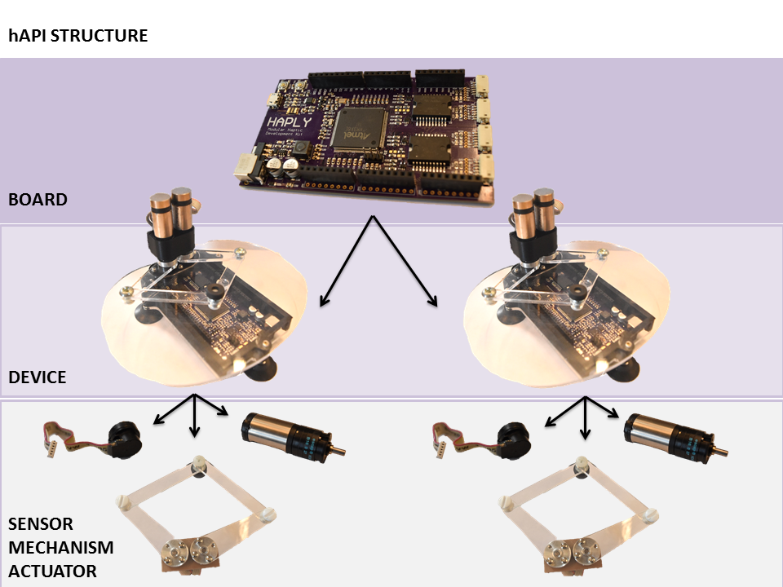

Similar to the Hapkit, we can see how the hAPI can be used to set up devices for a simulation. The Haply 2DoF is, as the name implies, a two degree-of-freedom device. It allows for users to achieve motion in a plane as well as controlling the device in the plane. We use two encoders and two actuators to achieve this control. Since the Haply Dev Board can support up to four actuators, you’re able to connect two 2DoF devices to the Haply Dev Board.

### *1.3.1. SUMMARY*

|  |
| --- |
| *IN SUMMARY:*   1. *Haptic systems involve a virtual environment which simulates a physical interaction. The virtual environment display can include different sensory modalities like audial and visual displays alongside some form of touch display (this is haptics after all!* 2. *Haptic systems are partitioned according to the functionality of the computer and control board that they are composed of.* 3. *The components of the system run at rates that are determined, in large part, by our sensory perception* 4. *The Haply Dev Board and Hapkit function with slightly different architectures based on the different limitations of their hardware* 5. *The hAPI is the interface that connects the device to the computer.* 6. *The architecture of the hAPI allows us to modularly construct different haptic platforms from their underlying components* |

# 2. GUIDED EXAMPLES

The guided examples in the following sections will demonstrate some basic examples of how to use the Hapkit and Haply Dev Board to develop your own haptic simulations. These demonstrations are built using Processing which is an open source development environment initially developed at the MIT Media Lab. We chose Processing as an initial platform to develop one because of the huge volume of support and example materials. Processing is built upon the Java programming language. We urge you to check out [Processing.org](https://processing.org/) to view examples and sample code. While we’ve developed the hAPI as an interface between these low-cost haptic platforms, we’re not experts in the Processing framework. If you think you can do a better job in your example, you’re probably right! Good luck!

## 2.1. HAPKIT SIMULATION WORKFLOW

Performing a haptic simulation using the Hapkit system requires two parts: (1) the haptic simulation and rendering being performed on the hapkit hardware (Arduino board system), and, (2) the animation being performed on the PC.

We’ll start first with the haptic simulation and virtual environment. The simulation loop runs at a frequency of 1kHz and will perform position sensor update, simulation physics calculations, and device torque renderings using only initialized settings if no input is received from the PC. The haptic simulation can run whether or not the hapkit is connected to the users computer. However, the computer can be used to program graphic animations and control what’s being rendered on the virtual environment contained on the Hapkit. If new instructions are sent from the computer and then received by the Hapkit, the parameters of the virtual environment will be updated and all calculations will be performed with the updated values. The Hapkit then transmits back the information we want to visual to the PC for animation rendering.

The animation loop performed on the PC runs at a frequency of 40Hz (frequency can be varied though anything beyond 60Hz is not recommended since it can lead to some unwanted effects in data transmission). The animation loop dictates serial communication rates between the computer and the device. When the animation loop sends control variables to the simulation, this does two things: (1) The control variables on the simulation side will be updated, changing what’s being rendered by the device and also simulation parameters, and, (2) return data is requested by the computer. The simulation loop, after updating the virtual environment, then sends the requested variables for animation rendering to the computer. The animation loop running on the computer will update using the new information.

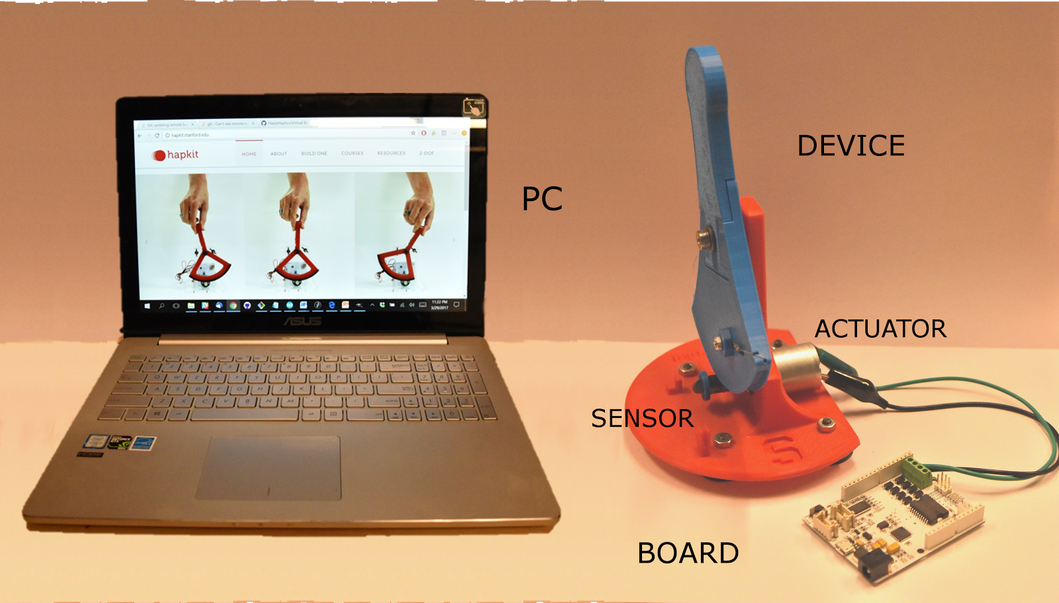

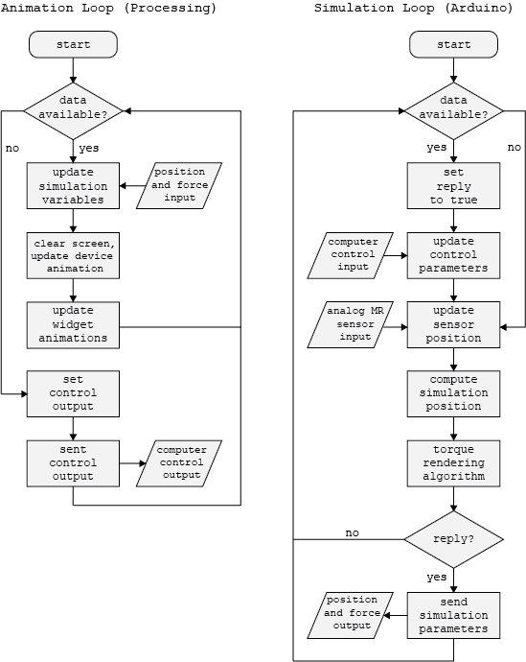

You can see how

## 2.2. Hapkit

[Examples Location](https://drive.google.com/drive/folders/0Bxt_y6pIhiprYnVLMExEZW9RWWs)



### 2.2.1. First Contact

Now we can walk through a basic example for the Hapkit to help you get up and running in no time. In this example we’ll be showing you how to set up an initial simulation so that you can learn some of the basics of how to setup the Hapkit for simulation. We’ll also show how users can switch between the types of environments being simulated using Processing on the computer.

### 2.2.2. arduino control loop

The first step in programming a simulation with the Hapkit is to program the virtual environment on the Hapkit in the Arduino IDE. To program your virtual environment on the Hapkit is fairly straightforward. You’ll first have to decide upon what type of simulation you want to display on the Hapkit. If you navigate to the   
“Hapkit_Kinematics_Simualtion.h” file, you’ll find a good example setup for how to program a virtual environment. There are several sections within this file that are of particular interest.

At the top of the file you’ll find the declarations of the variables that keep track of the states of the Hapkit as well as the virtual environment objects.

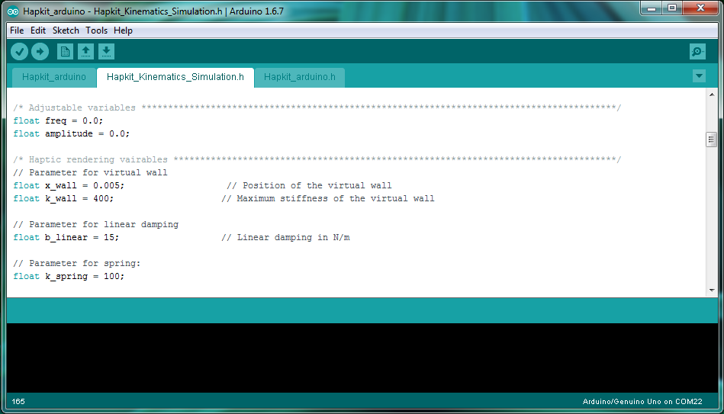

As you further explore, you’ll find a function called “*renderingAlgorithm*”. The rendering algorithm is called every millisecond by microcontroller and performs the simulation of the virtual environment. In this example, several virtual environments have been programmed along different switch-case paths. We’ll be able to later control which virtual environment is displayed from the computer but for not notice that each case has a different virtual environment coded.

Depending on the variable *functionNumber*, a different environment is simulated. When *functionNumber* is 0, no force is output to the device. When the *functionNumber* is 1, the device renders a virtual wall. If you look back to the above section (as seen in the previous figure), the position of the wall, x_wall, and the stiffness of the wall, k_wall, are defined. We are simulating what it’s like to touch a virtual spring, where the force we render is proportional to the stiffness of the spring and the amount we push into the spring. This is known as Hooke’s law. Many haptic simulations model the forces we feel through interactions by combining and simulating common physical elements like springs and dampers. You can see additional examples of these simulated physical elements in cases 2 and 3 below. They correspond to a simulated damping, like moving through a thick liquid, and a spring attached to the end of the device handle, respectively. When we get to the point of running the code, feel free to play with these parameters and see how your simulation changes!

***(warning: the maximum recommended value for k_wall is 700 N/m and for b_linear is 10 kg/s. If you go above these values the simulation may begin to feel unstable.)***

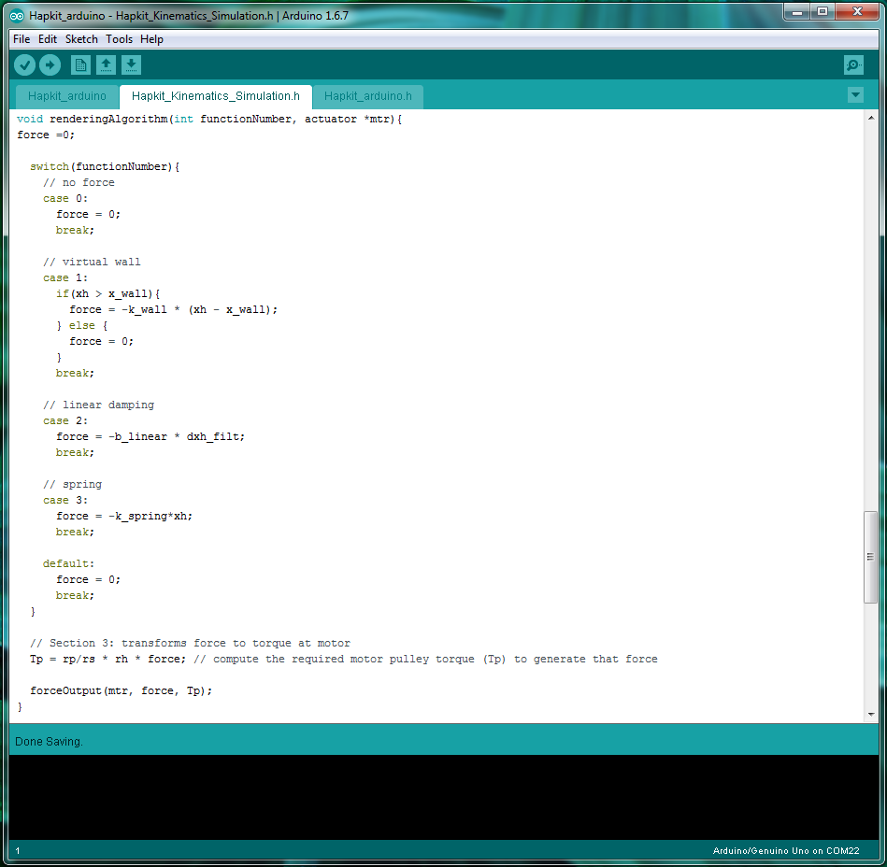

The *device_function* variable is set within the main Hapkit_arduino.ino file. This file handles the basic setup of the Hapkit as well as the communication between the Hapkit and an external computer. Within the loop function we check to see whether or not an external computer has sent us any information. If it has we go ahead and update the parameters of the simulation. This means that the simulation parameters that we want to changed, such as the device function, or the spring stiffness, can be passed from the computer to the Hapkit.

***note: you’ll notice that here we can also set a reply. While we don’t use this functionality in this example, in the next example you’ll see how we can choose data to send back to the computer so that we can display graphics on the computer screen.***

If no data was received from an external computer, we can jump right into simulating the virtual environments on our hapkit based on whichever *device_function* has been set.

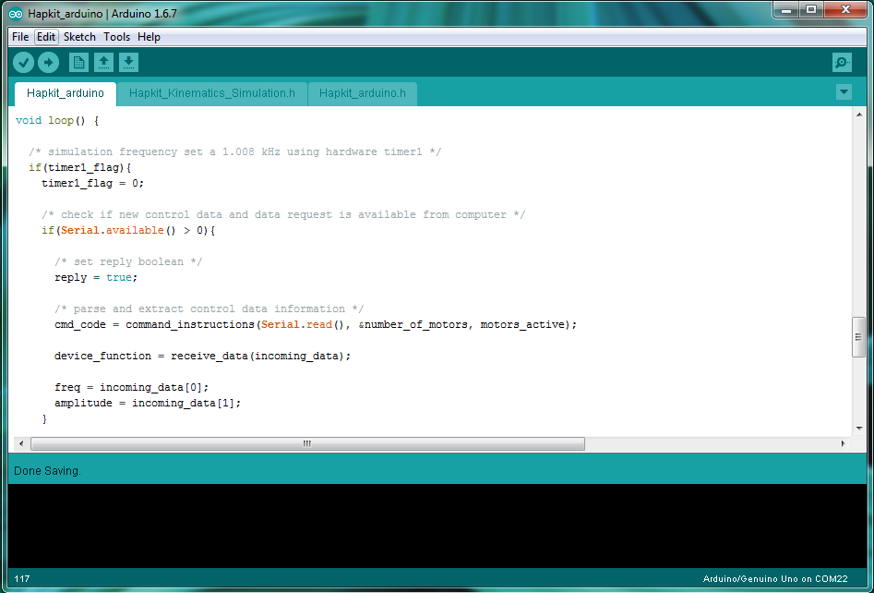

Go ahead and upload the code to your Hapkit board. Now we’re going to learn how we can control what environment is being rendered from our computers!

### 2.2.3. Processing setup

To set up the Processing sketch on the computer to run with the Hapkit we have to first open up a new sketch within the Processing IDE in the same folder as the hAPI. For now open up the example sketch “First Contact”.

Next we will initialize the hardware components by creating both a new *paddle_link* ***Board*** object and a *paddle* ***Device*** object. Within the hAPI, the ***Board*** class creates a ***Board*** object that handles the communication between the control board that is running the simulationand the computer. The control board, in this case the Hapkit board, is the physical piece of equipment that functions as the interface between our haptic robot and the computer.

Controls for the haptic robot itself is handled by the ***Device*** class creating a ***Device*** object, a virtual representation of the physical device and all the mechanical states.

Let’s run through the setup in this example starting with the ***Board*** object. In reference to the hAPI documentation, a ***Board*** object has the following constructor prototype:

|  |
| --- |
| **Board**(PApplet app, **String** portName, **int** speed); |

Where:

app - the parent Applet this class runs inside (this is your Processing sketch)

portName - serial port name that the Haply board is connected to (eg, “com10” for windows)

speed - The baud rate of serial data transfer

Since the PApplet parameter is specific to Processing, the main parameters that requires user input would be the portName string and the baud rate state. Now let’s take a look at the setup in this example.

|  |
| --- |
| **paddle_link = new Board**(this, **Serial.list()[0]**, **57600**); |

The haply_board object is created using a function from the Serial library specifying the string name of the port connection. this parameter can be replaced using the direct string name of the serial port that the Hapkit board is connected to. An example of such string names across different operating systems are:

windows - “COM10”

Linux - “/dev/ttyUSB0”

Mac - “/dev/tty.usbserial-A6004byf”

In this example, baud rate speed for serial communication was set at 57600. Higher or lower baud rates can be used, however, the initialized value must match on both the Arduino and Processing side for the serial communication setup.

After the ***Board*** object has been set up we can now populate the board with some ***Device***’s. In reference to the hAPI documentation, a ***Device*** object has the following constructor prototype:

|  |
| --- |
| **Device**(DeviceType device_type, **byte deviceID**, **Board deviceLink**); |

Where:

device_type - the degrees of freedom type to be implemented

deviceID - ID to be associated with device or device function

deviceLink - Board device is linking to

Now let’s take a look at the setup in this example:

|  |
| --- |
| **paddle = new Device**(degreesOfFreedom.HapticPaddle, device_function, paddle_link); |

In creating the ***Device*** object, we first dictate the type of device, specifically the degree-of-freedom of the device. In this case, a one-degree-of-freedom is specified using parameters of the Hapkit paddle. The needed ***Mechanism***, and the ***Actuator***, which handles things like the lengths of the links of the robot, the ports that motors are being driven from, are all automatically generated from this parameter. All these details can be manipulated by the adventurous user, but for most applications, users can stick with the standard mechanism, actuation, and sensing systems. The number of ports that the user defines must match the device type that the user passes to the function.

Next, we assign a device_function to the device. This parameter lets us control what type of haptic rendering the Hapkit device should be carrying out.

Finally, we assign which control board the device is attached to. This completes the connect between the haptic robot and the simulation running on the computer by allowing communication over the ports set up when we defined the ***Board*** object.

Below you can see how we execute this within the Processing framework. In the first line you see us import the serial communications library that the ***Board*** object relies upon to communicate with the Hapkit. We create a ***Board*** and ***Device*** object as described above. the hAPI contains an enumerated list of the different types of devices that it is compatible with called **DeviceType**. We must declare the enum so that we can later pass the **DeviceType** in as an argument while we setup **Device** object.

The additional variable declarations control the rate at which the Processing environment will draw to the screen, and in our case, pass data to the Hapkit. We set this to be 40 times per second, or 40 Hz, so that in later examples we can update the animation at speeds that appear continuous to the human eye.

In the setup we initialize the graphics properties and instantiate the ***Board*** and ***Device*** objects that we declared earlier. These steps setup the Hapkit to be used by the hAPI.

This example simply updates and loops through the device functions, or virtual environments, to be rendered on the Hapkit every 5 seconds and sends the data to the Hapkit 40 times per second.

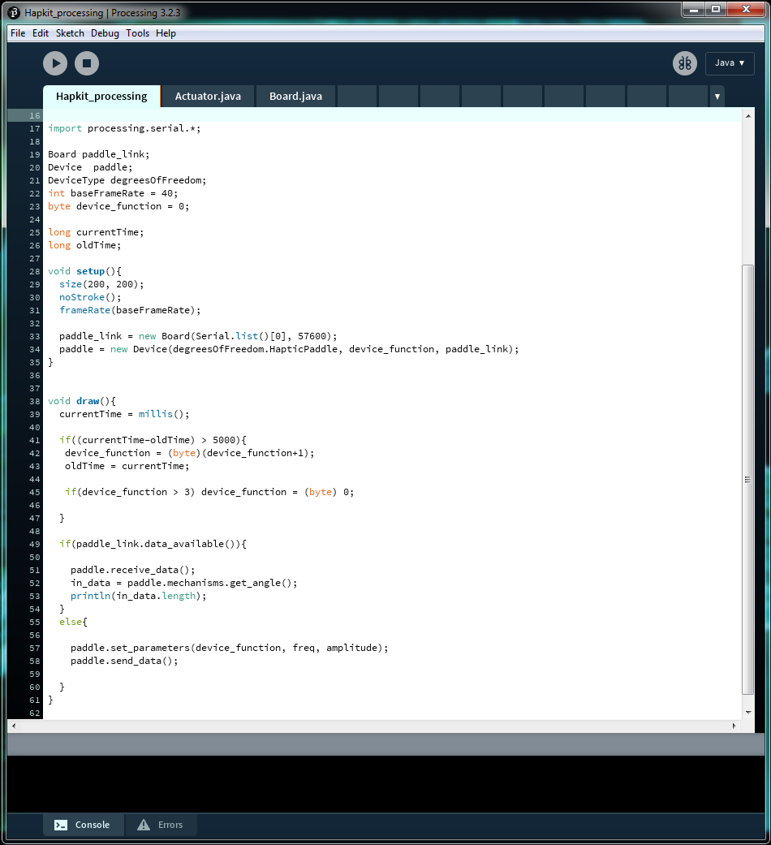

Go ahead and ensure that the Arduino code has been uploaded to the Hapkit. Once the code has been loaded onto the Hapkit, return the handle to the vertical position and click on the play button in the Processing IDE. A blank window should appear (we haven’t programmed any graphics just yet after all!) but you should be able to feel the forces that are being rendered by the Hapkit change every 5 seconds. You’re now controlling the Hapkit through your computer!

|  |
| --- |
| *Challenge:*  *See if you can write your own virtual environment to be displayed by the device. You can change the values you pass to the device using the “set_parameters” method. This will allow you to change properties like the wall stiffness or the amount of damping.* |

### ***2.2.4. Hello Wall***

LOCATION:

In this next example, we’ll be creating a graphic representation of the device in processing and render a virtual wall. As we move the device we will see the computer animation update to correspond to the motion of the Hapkit. When we collide with the virtual wall we will display an arrow on the handle that is proportional to the force being output.

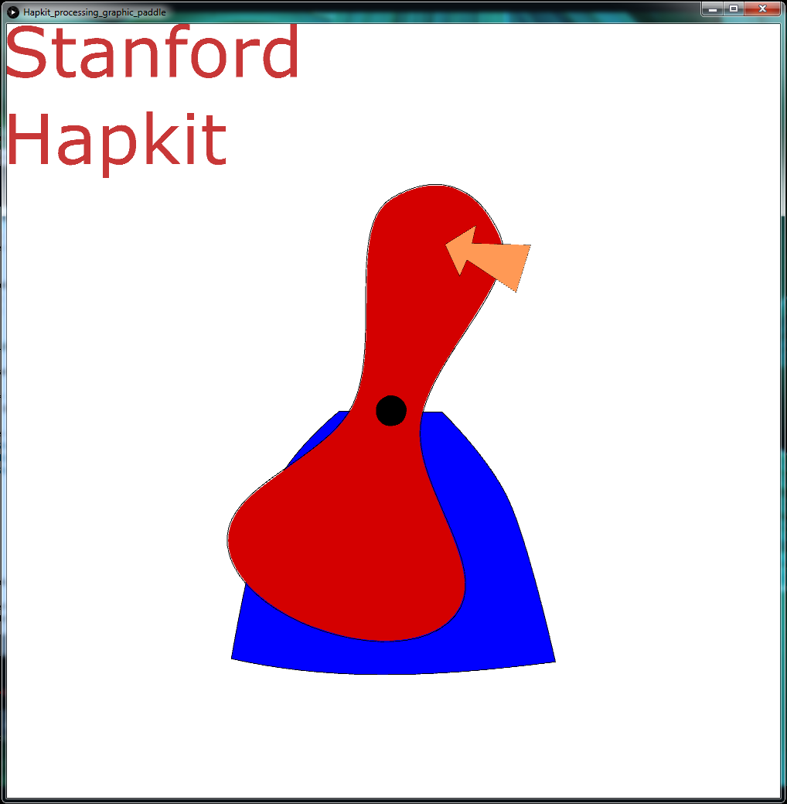

### 2.2.5. arduino control loop

In this example, the virtual environment and simulation running on the Arduino side needs to be able to accept simulation parameters from the PC side to determine what type of simulation to run on the Hapkit. After updating the simulation the Hapkit then needs to be able to send back information about the position of the device as well as what forces are being rendered. This allows us to generate a graphical representation can be seen on the PC side. 

To begin, the system checks to see if any new instructions are being sent from the PC. If a new command is available, the simulation parameters are updated accordingly and the system will send a reply to the PC on the relevant state information of the current simulation. The PC dictates the rate of serial communication by sending data requests periodically to the Hapkit.

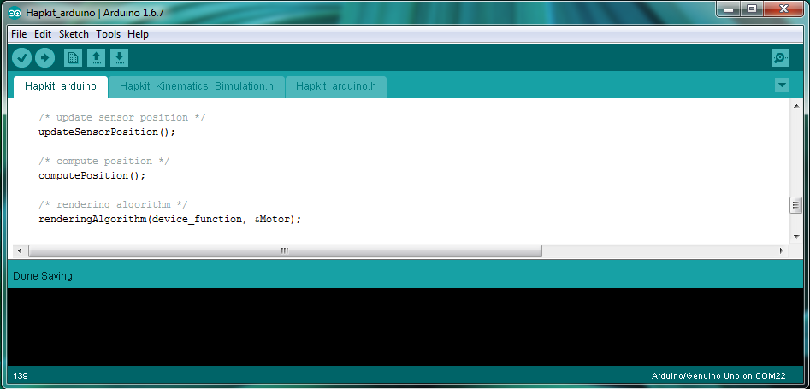

The haptics simulation and rendering is performed at a rate of 1.008kHz which is determined by the Hapkit hardware. The system will first take a new reading of the sensor position to determine if there were any changes in the angle of the device. Using this information, the current position of the device is calculated. Any contacts or rendered forces are then determined inside of the rendering algorithm and are output to the motors to simulate the sensation of force in the virtual environment.

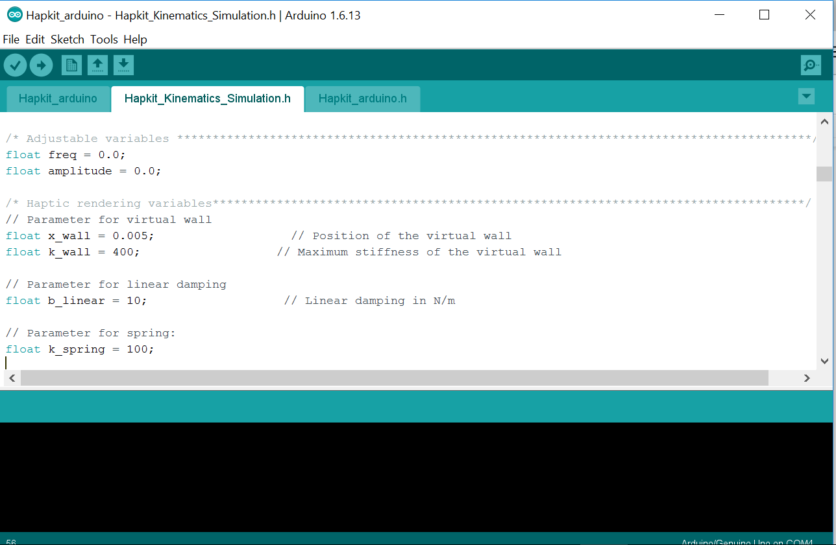

As mentioned, the Hapkit will occasionally receive requests from the PC to update the graphical animation. In the current example we set the outgoing data to be the angle of the device and the force that is acting on the handle. We’ll use this data to update the graphical environment on the Processing side in the next section.

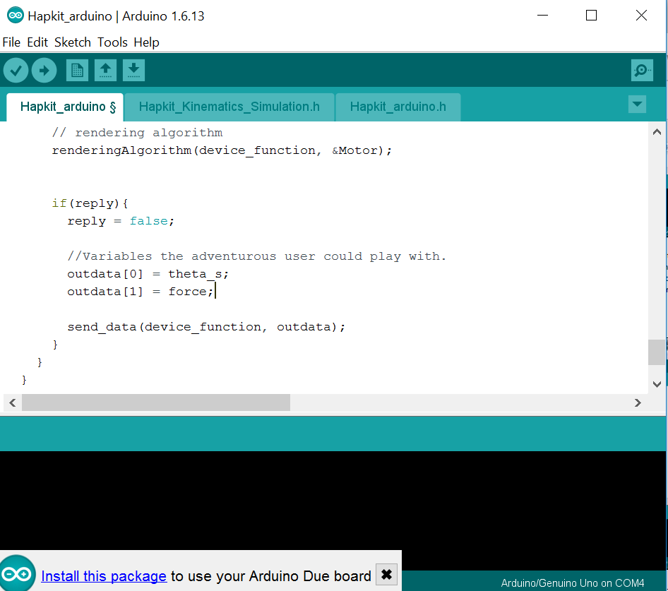

In this example we’ll be using the preprogrammed virtual wall which corresponds to the the case when the *functionNumber* variable is set to the *virtual wall* case, or case 1.



Now, we’ll learn how to program the *Processing* environment so that we’re able to visualize our simulation!

### 2.2.6. Processing setup

The beginning of a Processing sketch for the Hapkit must first declare a number of parameters. We need to import the appropriate serial communication library first followed by the declarations needed for using a device with the hAPI. Other parameters that are set to declare the variables and graphic objects that will be used in the simulation.

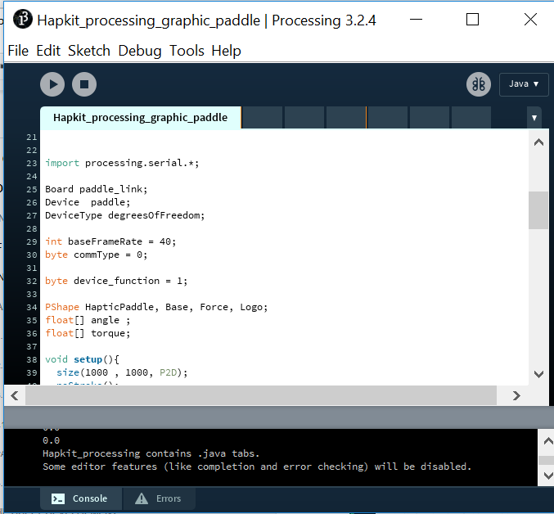

The Processing setup needs to define all the graphical display parameters needed for an animation of the Hapkit device. In addition to this, setup also needs to initialize the hardware device to interact with the haptic simulation. Let us first start by setting up the display window to a desired size and set the frame rate parameter of the animation event. Since we are working in *Processing*, the animation event are all tasks carried out in the *draw*() loop.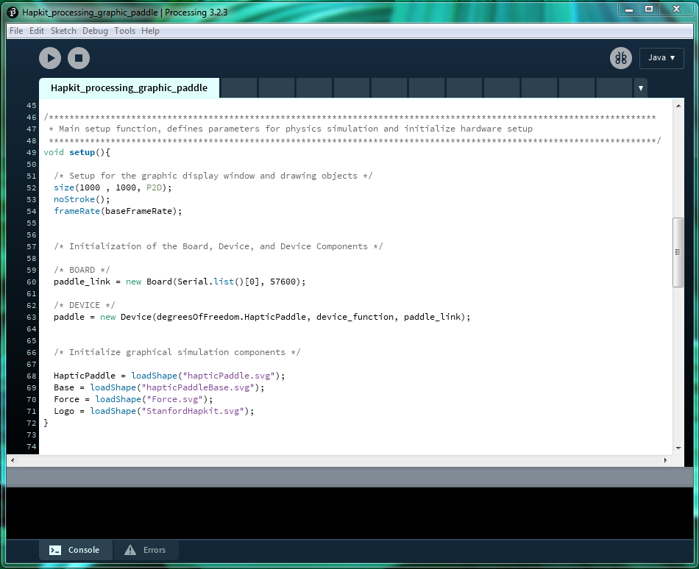

Next we will initialize the hardware components by creating both a new *paddle_link* board object and a *paddle* device object. Creating the *paddle_link* board object initialize the Serial link between the PC. The *paddle* device object retains the simulation state information that will be received from the Hapkit hardware.

Finally, we can initialize and establish some graphical representation of the Hapkit device and the output force by loading graphic objects that will be drawn in the scene.

### 2.2.7. Processing draw

The processing draw function has two tasks that needs to be carried out. First the draw function handles serial communication with the paddle device by sending control parameters and receiving simulation state updates. If a new simulation state is received, then the graphical representation is updated.

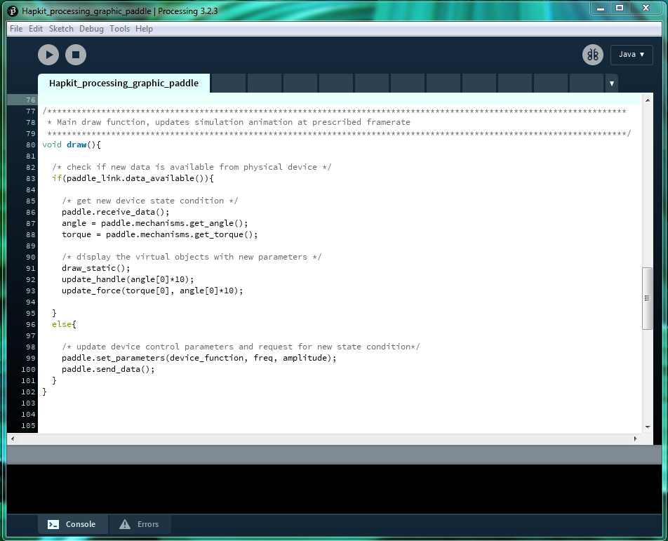

Let us first discuss the serial communication instructions dictated by this function. Recall from the previous section that new simulation state information is only received from the paddle device if new control parameters are sent from the PC. From this setup, the PC will always send control parameters if no new state information is available from the paddle device. This is just a level of redundancy to ensure that the state’s on the Hapkit are being set to what we want.

### 2.2.8. Processing animations

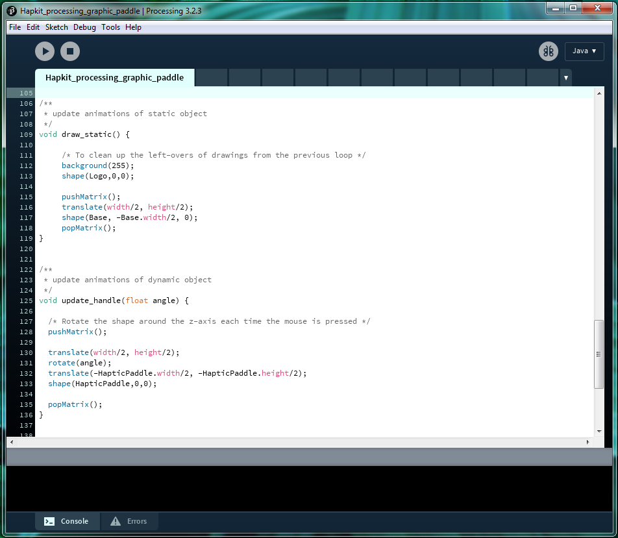

The animation for this example is divided into two sections: (1) the display of static elements, (2) the display of dynamic elements. The draw_static() function updates all static elements in the animations that needs to be updated. In this case, the base of the haptic paddle animation is updated here. The update_animation(float angle) function updates the animation of the dynamic elements. Here, the handle of the haptic paddle animation is updated based on the most recent angle input received.

Drawing in processing requires a bit of practice. Rather than setting the location and angle where you draw an object, the user actually translates the scene and renders the graphic at the origin. This is a bit odd at first but makes sense with a bit of practice. I urge you to checkout the plethora of [Processing tutorials](https://processing.org/tutorials/), and specifically the [2D Transformation tutorial](https://processing.org/tutorials/transform2d/) on *Processing*.org.

Go ahead and give the simulation a try. After flashing the Arduino code to the Hapkit, open up the Processing file corresponding to this tutorial titled, “Hapkit_First_Contact”. Press play in the processing window to run the sketch.

## 2.3. HAPLY SIMULATION WORKFLOW



Building a simulation with the Haply Dev Kit differs significantly from the Hapkit because it allows for the development of the simulation entirely on board the computer. Generating a haptic simulation using the Haply system can be divided into three main sections: (1) system setup, (2) animation event, (3) haptic simulation event. Before starting, please ensure the firmware Haply_Arduino_Control.ino is loaded onto the haply control board. The Haply system does not require any user code to be loaded on the Arduino side and instead is programmed entirely within the Processing environment.

All calculations needed to generate a haptic simulation is performed on the PC side using the Haply system. The Haply board acts as a communication link between the physical mechanical hardware and the virtual simulation environment.

The virtual simulation environment generated on the PC side sends to the Haply board torque forces that needs to be generated by the physical mechanism, likewise, the Haply board provides feedback by gathering angular information from the encoder sensors and passing this information back to the virtual simulation environment. No physics environment simulation calculations are performed directly on the Haply board.

The virtual simulation environment is comprised of two timed events (1) the animation event, (2) the haptic simulation event. These events are analogous to threads but are much simpler in function within the confines of the Processing development environment.

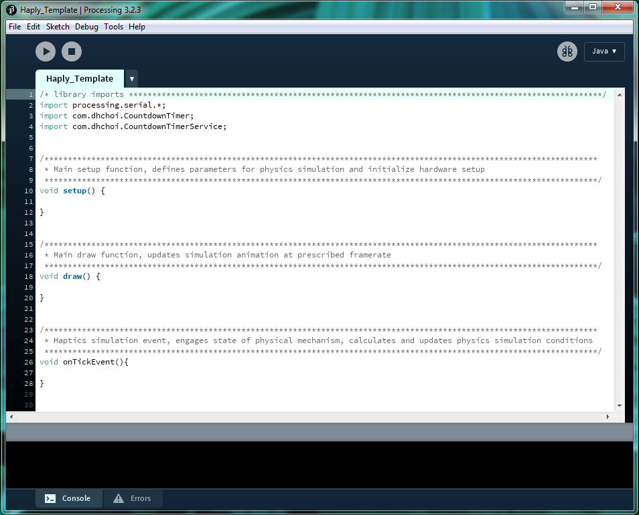

The main timed event is the simulation event loop. The simulation event loop runs at a frequency of 1kHz, and waits for new angle data from the physical mechanism before performing new physics simulation calculations. During the simulation calculations, all event and state variables are updated and finally all torque calculations are determined. After calculations are completed, the new torque data is transmitted to the physical mechanism for rendering.

The other timed event is the animation event loop. The animation event loop can run at a frequency of 40-60Hz . The function of the animation event is to update the current animation display with the most recent data produced by the simulation event loop.

Relating to Processing, the *setup*() and *draw*() functions are the system setup and animation event sections of the haptic simulation in terms of organisation. The *setup*() function only runs once while the *draw*() function runs continuously at the established frame rate. To implement another loop for the purposes of haptic simulation, a timer was set up using the *CountdownTimer* library we imported during the Getting Started section of this documentation. The *onTickEvent*() is the timer’s specific tick event handler, meaning that the *onTickEvent*() function also runs continuously at a rate dictated by the countdown timer’s tick event setup. In all Haply examples, this rate is set to 1kHz.

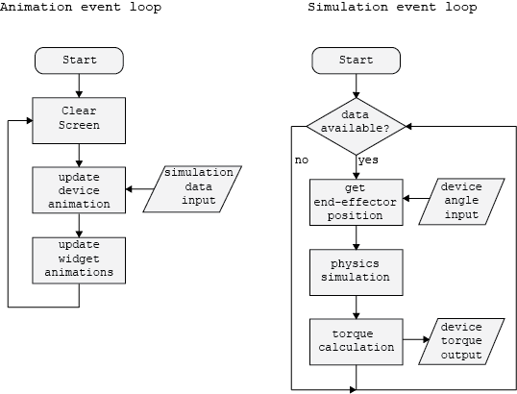

The above figure demonstrates the structure of how we build our simulation. The animation loop updates at around 40-60 Hz while the simulation event loop updates at 1kHz. This allows us to save processing power for the simulation as updating the animation faster than the 60Hz will require the computer’s resources while not having any noticeable improvement to the user’s visual perception.

## 2.4. Haply Dev Board

[Examples Location](https://drive.google.com/drive/folders/0Bxt_y6pIhipreDVYUWJTeHhGRkU)

### 2.4.1. Hello Wall

Now let’s walk through a basic example of generating a virtual wall using the Haply board and a pantograph mechanism. The user can interact with the simulation environment using the pantograph mechanism and will have free movement until interaction with the virtual wall. In this example, we will show in detail the (1) system setup, (2) animation event, and (3) haptic simulation event sections needed to generate a haptic simulation.

Before starting, it needs to be noted that a scaling factor is needed to translate the dimensions of the physical hardware measured in SI units (meters) to the display screen dimensions (pixels). All simulation parameters are calculated in terms of SI units and all animations use a translation of the calculated parameters to display the animated representations in pixels. Please refer to the appendix for a detailed explanation of this scaling.

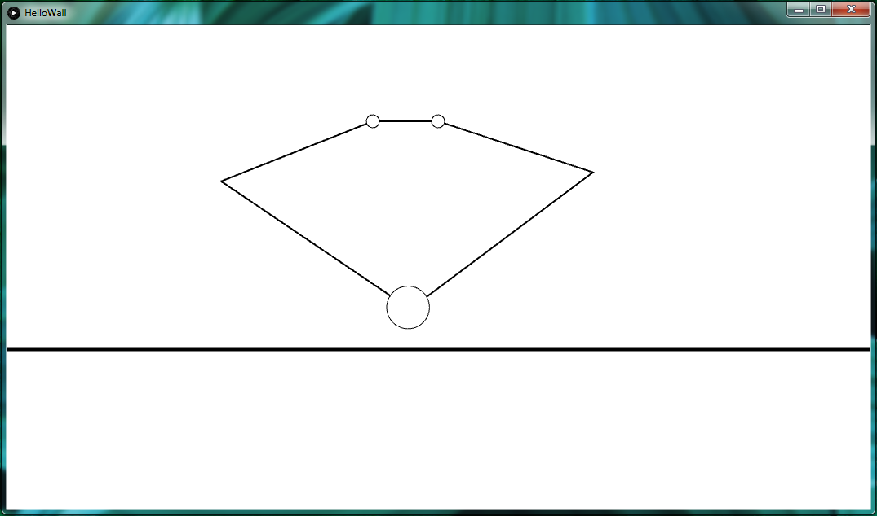

### 2.4.2. System Setup

The system setup needs to define and initialize parameters so that they can be used by both the animation event and the haptic simulation event respectively. In addition to this, system setup also initializes the hardware device (in this example the pantograph mechanism controlled by the Haply control board) so that it can interact with the haptic simulation event.

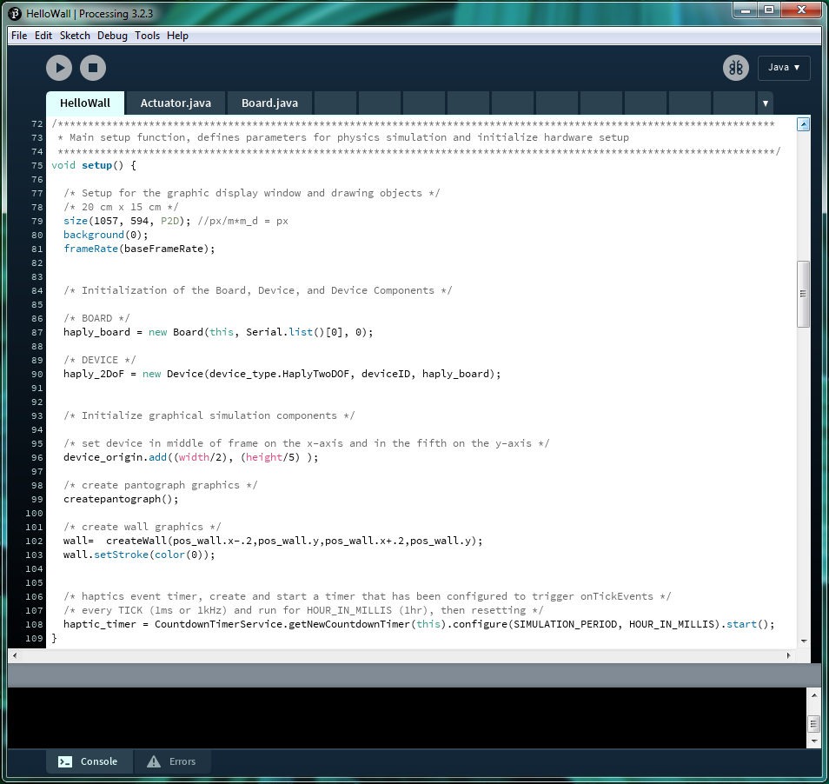

Let us first start by setting up the display window to a desired size and set the frame rate parameter of the animation event. Since we are working in Processing, the animation event are all tasks carried out in the draw() loop.

Next we will initialize the hardware components by creating both a new *haply_board* object and a *haply_2DoF* device object. Within the hAPI, the ***Board*** class creates a ***Board*** object that handles the communication between the control board and the computer that is running the simulation. The control board, in this case the Haply board, is the physical piece of equipment that functions as the interface between our haptic robot and the computer.

Controls for the haptic robot itself is handled by the ***Device*** class creating a ***Device*** object, a virtual representation of the physical device and all the mechanical states. In the same way that a physical device can be broken down into various subcomponents, the physical mechanism of the device, the actuators that move the device, and the sensor that detect changes in state of the device, a ***Device*** object is composed of the ***Mechanism***, ***Actuator***, and ***Sensor*** objects.

Let’s run through the setup in this example starting with the ***Board*** object. In reference to the hAPI documentation, a ***Board*** object has the following constructor prototype:

|  |
| --- |
| **Board**(PApplet app, **String** portName, **int** speed); |

Where:

app - the parent Applet this class runs inside (this is your Processing sketch)

portName - serial port name that the Haply board is connected to (eg, “com10” for windows)

speed - The baud rate of serial data transfer

Since the PApplet parameter is specific to Processing, the main parameters that requires user input would be the portName string and the baud rate state. Now let’s take a look at the setup in this example.

|  |
| --- |
| **haply_board = new Board**(this, **Serial.list()[0]**, **0**); |

The haply_board object is created using a function from the Serial library specifying the string name of the port connection. this parameter can be replaced using the direct string name of the serial port that the Haply board is connected to. An example of such string names across different operating systems are:

windows - “COM10”

Linux - “/dev/ttyUSB0”

Mac - “/dev/tty.usbserial-A6004byf”

In this example, you would note that a baud rate speed of zero was specified, this is not a mistake. Since the Haply control board connects to the computer using the Native Serial USB port, specifying a baud rate speed of zero indicates an unlimited baud rate speed.

After the ***Board*** object has been set up we can now populate the board with some ***Device***’s. We are able to populate the control board with as many devices as we can drive with the actuator outputs. In the case of the Haply Development Board, we can drive up to four independent motors with the hardware that is built into the board, it is possible to drive four 1-degree-of-freedom devices, and two 2-degree-of-freedom devices. In reference to the hAPI documentation, a ***Device*** object has the following constructor prototype:

|  |
| --- |
| **Device**(DeviceType device_type, **byte deviceID**, **Board deviceLink**); |

Where:

device_type - the degrees of freedom type to be implemented

deviceID - ID to be associated with device

deviceLink - Board device is linking to

Now let’s take a look at the setup in this example:

|  |
| --- |
| **haply_2DoF = new Device**(device_type.HaplyTwoDOF, deviceID, haply_board); |

In creating the ***Device*** object, we first dictate the type of device, specifically the degree-of-freedom of the device. In this case, a two-degree-of-freedom is specified using parameters of the Haply pantograph. The needed ***Mechanism***, and the number of ***Actuator***s and ***Sensor***s that compose the haptic robot, which handle s things like the lengths of the links of the robot, the ports that motors are being driven from, and the resolution that the sensors can detect motion, are all automatically generated from this parameter. All these details can be manipulated by the adventurous user, but for most applications, users can stick with the standard mechanism, actuation, and sensing systems. The number of ports that the user defines must match the device type that the user passes to the function.

Next, we assign a unique ID to the device. This parameter lets us differentiate between different multiple haptic robots assigned to the same control board, allowing us to read sensors and control actuators for a specific device.

Finally, we assign which control board the device is attached to. This completes the connect between the haptic robot and the simulation running on the computer by allowing communication over the ports set up when we defined the ***Board*** object.

After setting up the graphic display and initializing the hardware, the graphical simulation components can now be initialized. First we set the device to be on the middle of the display frame and in the fifth portion on the vertical axis by adjusting the coordinates of the device origin.

Next we create the graphical representations of the pantograph and the wall object. Calculations within the simulation space are performed using SI units, as we will see in the following section, representing information from the simulation to animation requires a scaling factor since a screen displays objects in terms of pixels. In this example, the wall object is represented by a line drawn horizontally across the display space.

Finally, we create and start a timer for the haptic simulation event. The timer used is from the Countdown Timer library by Dong Hyun Choi from the Processing reference libraries.

### 2.4.3. Animation Event

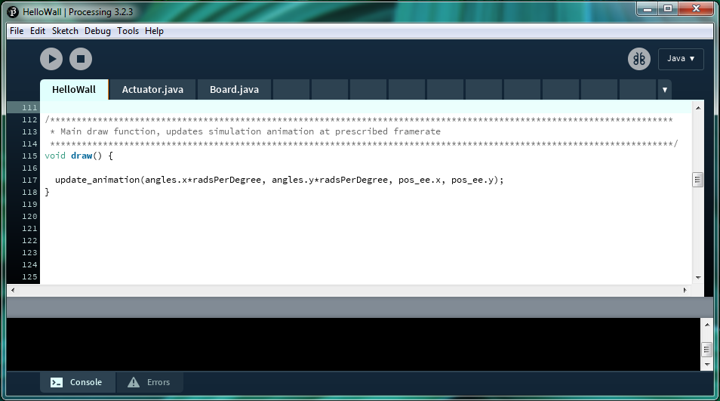

The animation event updates the simulation animation using the most recent position states calculated by the simulation event. All the animations associated with each virtual simulation object needs to be updated. In this example, this includes the dynamic pantograph, and the static wall. Let us go into more detail as to what is happening during an animation event.

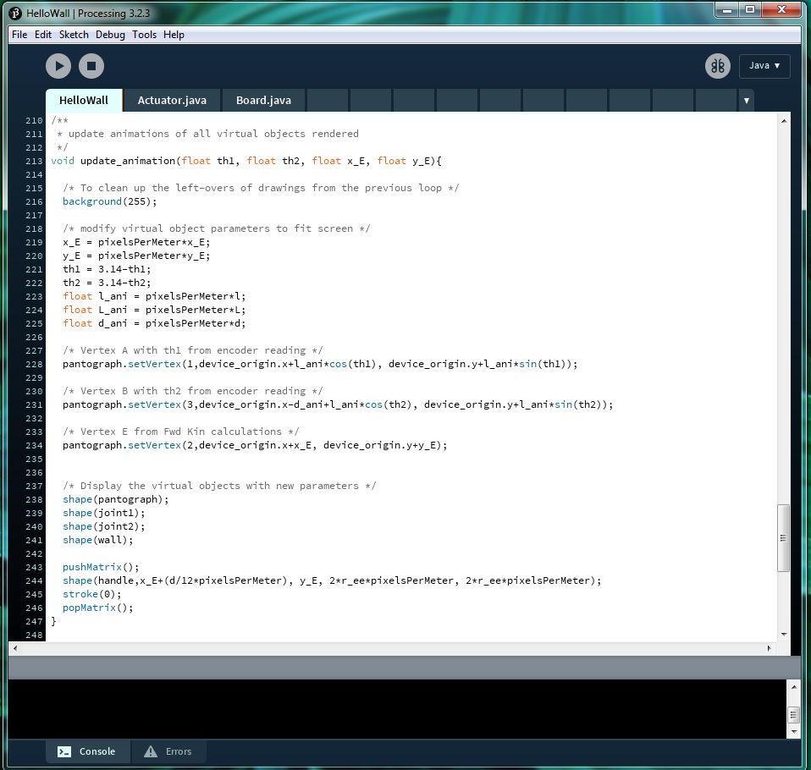

Before determining the parameters of the new animation using the most recent state updates from the simulation, we first need to scale the parameters given to us in terms of SI units to pixels so that they look proportionally appropriate in the display window that was set up. Please refer to the appendix on how this is done.

Next we update the pantograph animation parameters by updating the positions of the three vertices of the pantograph device, the end-effector, and the two arm linkages. The two motor arm links are updated using the angle data received from the encoders of the physical hardware, and performing trigonometric calculations to determine their final states. The end-effector position is representative of the calculated end-effector position from the simulation event, scaled with respect to the device origin.

### 2.4.4. Haptic Simulation Event

The haptic simulation event’s main tasks are to take new information from the hardware device as input for simulation update, perform physics calculations based on the simulation parameters, and finally send required torque rendering information to the hardware device so that the appropriate forces can be generated based on simulation parameters.

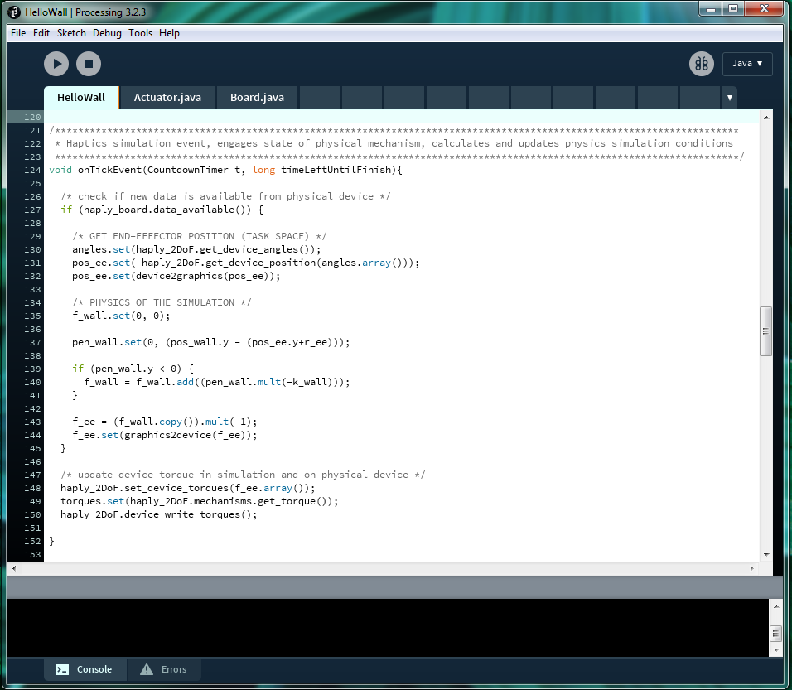

To begin, we first check to see if new angular data is available from the hardware device. If new angle data is available, the angle variables of the device are updated, and the end-effector position is calculated based on this new data input.

Next, physics calculations are performed based on the parameters of the simulation. In this example case, we are focusing on the interaction between the end-effector of the pantograph and the virtual wall. We first calculate the distance between the pantograph and the virtual, only the y-axis information is relevant since the virtual wall is horizontal across the screen.

If the distance between the end-effector and the wall is less than zero, this means that the end-effector of the device has come in contact with the wall and has penetrated the wall, at this point, a force needs to be calculated and generated on the physical device to simulate the end-effector hitting the wall and to counter the end-effector from moving any further into penetrating the wall.

After the force is determined, a mapping is made from this force to torques that the motors need to generate to render this force. Finally, the physical device is sent the torque parameters for rendering.

### 2.4.5. Hello Ball

Now let’s walk through an example where two dynamic objects are interacting with one another. In this case, the end-effector of the pantograph, and a virtual ball. The user can interact with the simulation environment using the pantograph mechanism and will have free movement until interaction with the virtual ball. The virtual ball is affected by a ‘downward’ force and is confined in a 2D cradle generated by three walls. In this example, we will show in detail the (1) system setup, (2) animation event, and (3) haptic simulation event sections needed to generate a haptic simulation.

Before starting, it needs to be noted that a scaling factor is needed to translate the dimensions of the physical hardware measured in SI units (meters) to the display screen dimensions (pixels). All simulation parameters are calculated in terms of SI units and all animations use a translation of the calculated parameters to display the animated representations in pixels. Please refer to the appendix for a detailed explanation of this scaling.

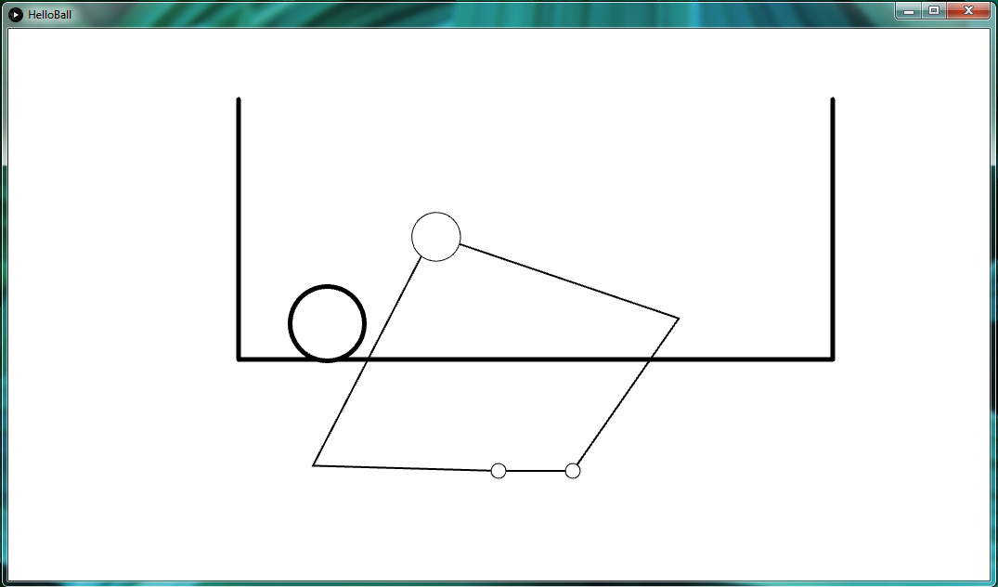

### 2.4.6. System Setup

The system setup needs to define and initialize parameters so that they can be used by both the animation event and the haptic simulation event respectively. In addition to this, system setup also needs to initialize the hardware device (in this example the pantograph mechanism controlled by the Haply control board) so that it can interact with the haptic simulation event.

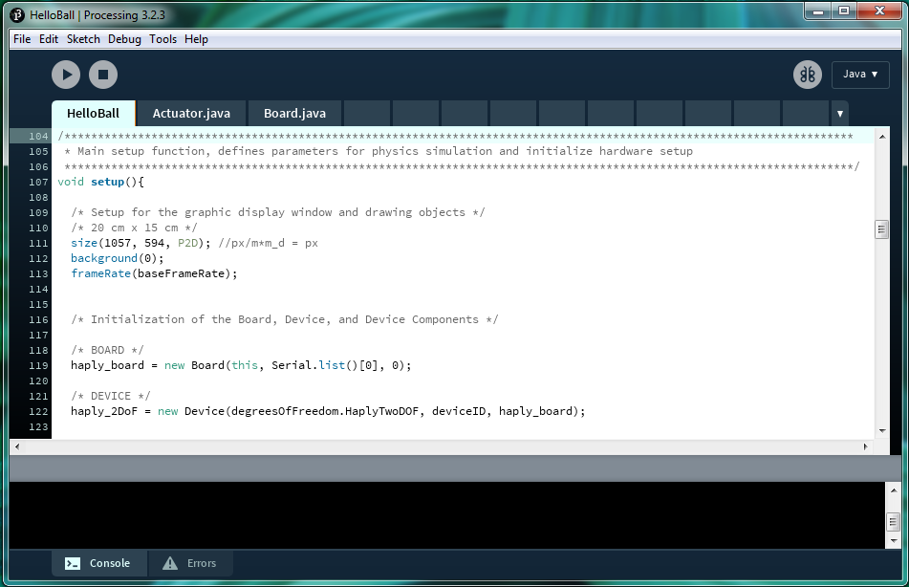

Let us first start by setting up the display window to a desired size and set the frame rate parameter of the animation event. Since we are working in Processing, the animation event are all tasks carried out in the draw() loop.

Next we will initialize the hardware components by creating both a new *haply_board* object and a *haply_2DoF* device object. Within the hAPI, the ***Board*** class creates a ***Board*** object that handles the communication between the control board and the computer that is running the simulation. The control board, in this case the Haply board, is the physical piece of equipment that functions as the interface between our haptic robot and the computer.

Controls for the haptic robot itself is handled by the ***Device*** class creating a ***Device*** object, a virtual representation of the physical device and all the mechanical states. In the same way that a physical device can be broken down into various subcomponents, the physical mechanism of the device, the actuators that move the device, and the sensor that detect changes in state of the device, a ***Device*** object is composed of the ***Mechanism***, ***Actuator***, and ***Sensor*** objects.

Let’s run through the setup in this example starting with the ***Board*** object. In reference to the hAPI documentation, a ***Board*** object has the following constructor prototype:

|  |
| --- |
| **Board**(PApplet app, **String** portName, **int** speed); |

Where:

app - the parent Applet this class runs inside (this is your Processing sketch)

portName - serial port name that the Haply board is connected to (eg, “com10” for windows)

speed - The baud rate of serial data transfer

Since the PApplet parameter is specific to Processing, the main parameters that requires user input would be the portName string and the baud rate state. Now let’s take a look at the setup in this example.

|  |
| --- |
| **haply_board = new Board**(this, **Serial.list()[0]**, **0**); |

The haply_board object is created using a function from the Serial library specifying the string name of the port connection. this parameter can be replaced using the direct string name of the serial port that the Haply board is connected to. An example of such string names across different operating systems are:

windows - “COM10”

Linux - “/dev/ttyUSB0”

Mac - “/dev/tty.usbserial-A6004byf”

In this example, you would note that a baud rate speed of zero was specified, this is not a mistake. Since the Haply control board connects to the computer using the Native Serial USB port, specifying a baud rate speed of zero indicates an unlimited baud rate speed.

After the ***Board*** object has been set up we can now populate the board with some ***Device***’s. We are able to populate the control board with as many devices as we can drive with the actuator outputs. In the case of the Haply Development Board, we can drive up to four independent motors with the hardware that is built into the board, it is possible to drive four 1-degree-of-freedom devices, and two 2-degree-of-freedom devices. In reference to the hAPI documentation, a ***Device*** object has the following constructor prototype:

|  |
| --- |
| **Device**(DeviceType device_type, **byte deviceID**, **Board deviceLink**); |

Where:

device_type - the degrees of freedom type to be implemented

deviceID - ID to be associated with device

deviceLink - Board device is linking to

Now let’s take a look at the setup in this example:

|  |
| --- |
| **haply_2DoF = new Device**(device_type.HaplyTwoDOF, deviceID, haply_board); |

In creating the ***Device*** object, we first dictate the type of device, specifically the degree-of-freedom of the device. In this case, a two-degree-of-freedom is specified using parameters of the Haply pantograph. The needed ***Mechanism***, and the number of ***Actuator***s and ***Sensor***s that compose the haptic robot, which handle s things like the lengths of the links of the robot, the ports that motors are being driven from, and the resolution that the sensors can detect motion, are all automatically generated from this parameter. All these details can be manipulated by the adventurous user, but for most applications, users can stick with the standard mechanism, actuation, and sensing systems. The number of ports that the user defines must match the device type that the user passes to the function.

Next, we assign a unique ID to the device. This parameter lets us differentiate between different multiple haptic robots assigned to the same control board, allowing us to read sensors and control actuators for a specific device.

Finally, we assign which control board the device is attached to. This completes the connect between the haptic robot and the simulation running on the computer by allowing communication over the ports set up when we defined the ***Board*** object.

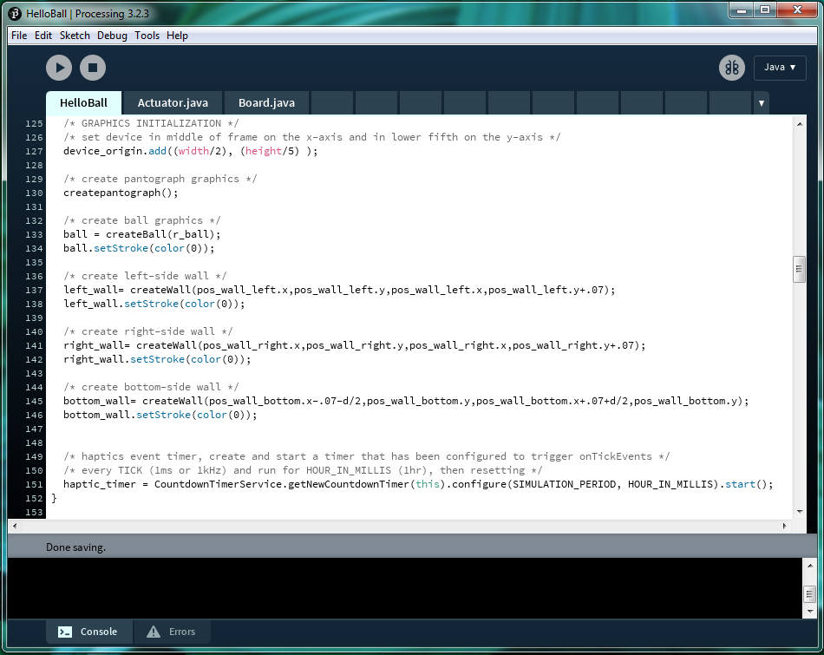

After setting up the graphic display and initializing the hardware, the graphical simulation components can now be initialized. First we set the device to be on the middle of the display frame and in the fifth portion on the vertical axis by adjusting the coordinates of the device origin.

Next we create the graphical representations of the pantograph, the ball, and the wall objects. In this example three virtual wall objects are created to interact with the ball object. A wall is created on left side, right side, and bottom, forming a box with one open side. The ball is bounded by this box, and also interacts with the end-effector of the pantograph device.

Calculations within the simulation space are performed using SI units, as we will see in the following section, representing information from the simulation to animation requires a scaling factor since a screen displays objects in terms of pixels. In this example, the wall object is represented by a line drawn horizontally across the display space.

Finally, we create and start a timer for the haptic simulation event. The timer used is from the Countdown Timer library by Dong Hyun Choi from the Processing reference libraries.

### 2.4.7. Animation Event

As you may have noticed, the orientation of the virtual pantograph is inverted compared to the example shown in Hello Wall. This inversion is implemented by scaling before the animation is updated.

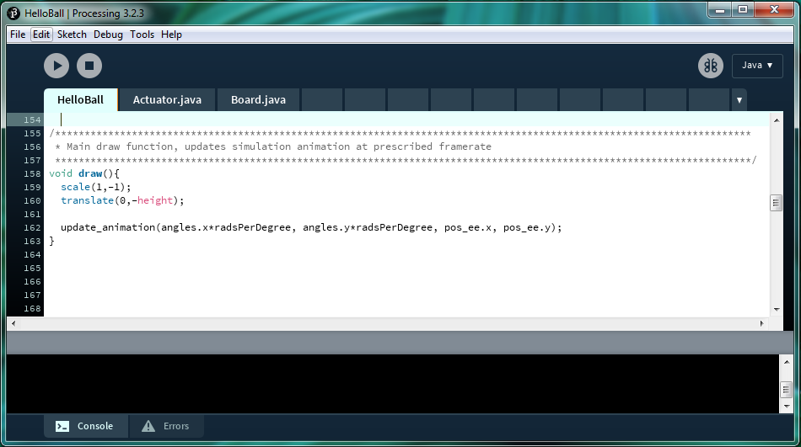

The animation event updates the simulation animation using the most recent position states calculated by the simulation event. All the animations associated with each virtual simulation object needs to be updated. In this example, this includes the pantograph, and the wall. Let us go into more detail as to what is happening during an animation event.

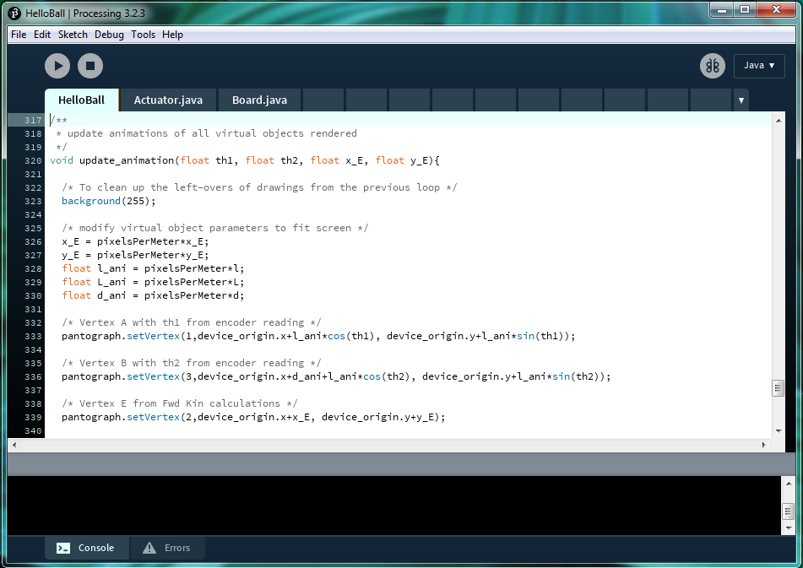

Before determining the parameters of the new animation using the most recent state updates from the simulation, we first need to translate or scale the parameters given to us in terms of SI units to pixels so that they look proportionally appropriate in the display window that was set up. After this is done, all vertices of the graphics associated with the pantograph is updated with the new information.

Next we update the pantograph animation parameters by updating the positions of the three vertices of the pantograph device, the end-effector, and the two arm linkages. The two motor arm links are updated using the angle data received from the encoders of the physical hardware, and performing trigonometric calculations to determine their final states. The end-effector position is representative of the calculated end-effector position from the simulation event, scaled with respect to the device origin.

Please take note that since the device is in an inverted orientation in comparison to the HelloWall example, the vertex updates use different scaling to update the pantograph vertices.

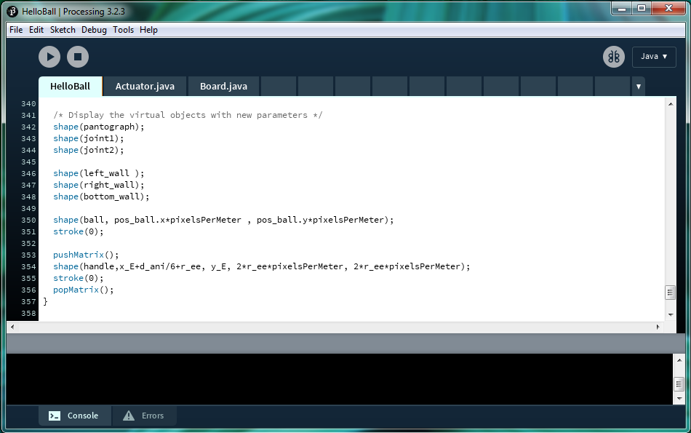

The graphical animation is then updated for the rest of the graphical objects. the position of the ball is updated using calculations determined in the haptic simulation event.

### 2.4.8. Haptic Simulation Event

The haptic simulation events takes angle inputs received from the device hardware and updates the virtual environment accordingly. This event also performs the necessary physics calculations required and finally sends torque renderings to the device hardware.

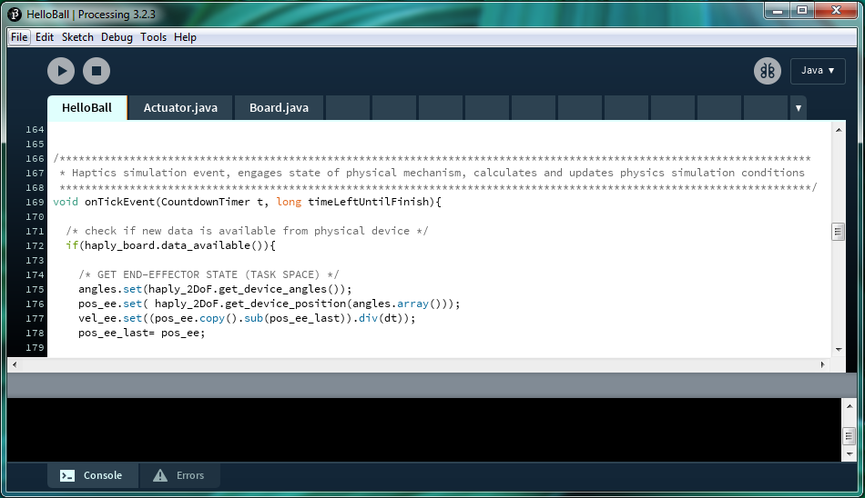

To begin, we first check to see if new angular data is available from the hardware device. If new angle data is available, the angle variables of the device are updated, and the end-effector position is calculated based on this new data input.

Next, physics calculations are performed based on the parameters of the simulation. In this example case, we are focusing on the interaction between the end-effector of the pantograph with the ball, the ball with the three walls, and a ‘gravitational’ force that forces the ball in a downward direction.

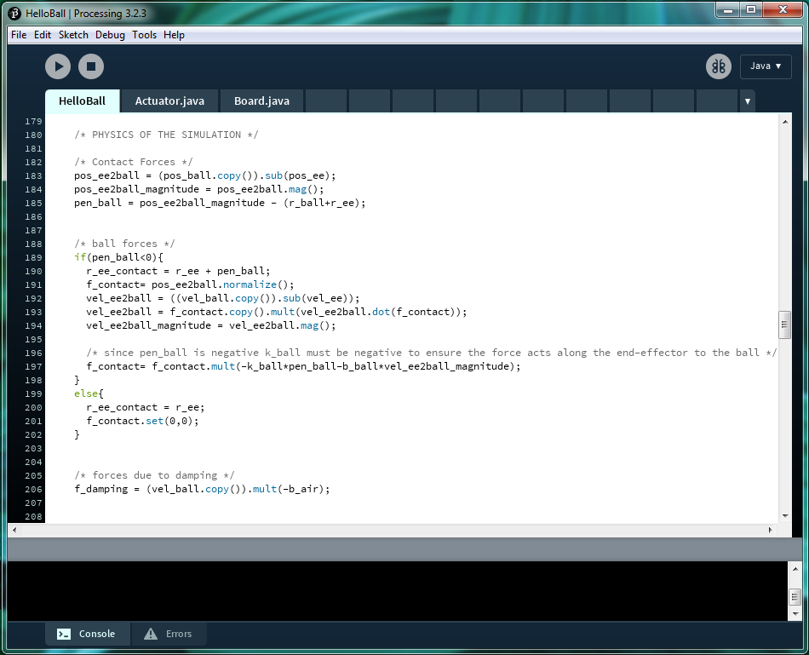

We first determine the position of the ball and its position and interact with the end-effector of the pantograph. If the end-effector comes in contact with the ball, the relevant force effects for both the ball and the end-effector are calculated. If there is no contact, the end-effector has free movement.

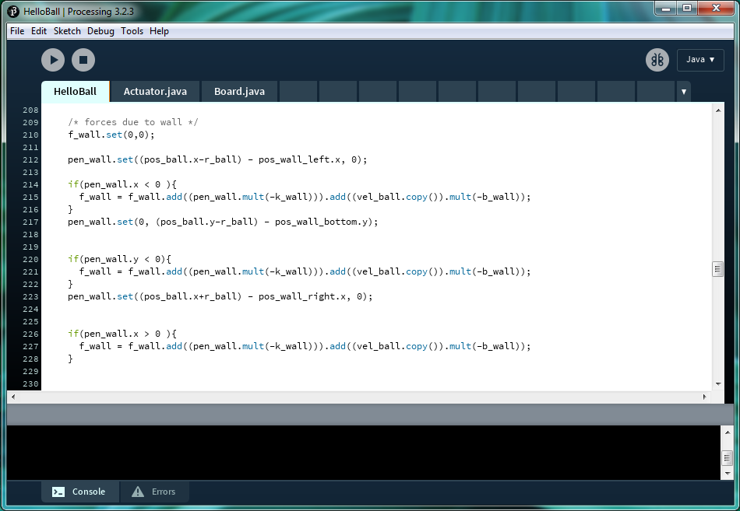

After determining the interaction between the ball and the end-effector, we now need to figure out the force interaction between the ball and each of the three walls. Since each wall is located on either a horizontal or vertical axis, you only need to look at the interaction on the x-axis for the left and right wall, and the y-axis for the bottom wall.

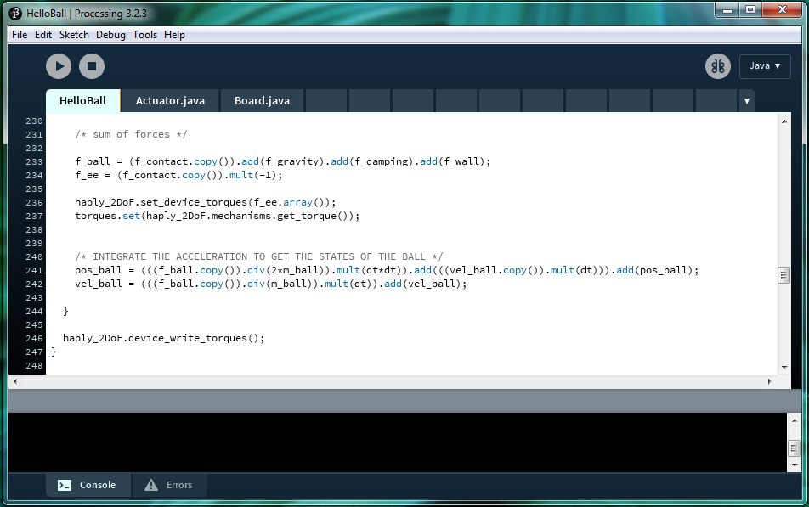

Once all the forces have been determined, they can be summed. Since there are two dynamic objects, the ball and the end-effector, the forces for both device needs to be determined. The force acting on the ball determines its movement in the virtual environment, and the force acting on the end-effector is needed to determine the amount of force the physical device needs to generate.

### 2.4.9. Gravity

So far in our examples we have only dealt with one active dynamic object, the end-effector of the pantograph. Even in the HelloBall example, the ball in question only reacted to the forces produced by the end-effector. Although there are states where the ball can also actively affect the end-effector, only only happens as a response to the effects of the end-effector.

In this example, we will produce two actively dynamic objects interacting with one another, a flying saucer controlled by the end-effector of the pantograph, and an asteroid controlled by some gravitational parameters set within the generated 2D virtual environment. **\*\* note: the title gravity here is fake as it’s just a virtual spring connected to the center of the virtual environment but it’s just here to play on the theme. If you want try replacing the force with the real law of attraction. Just be careful though as objects approach zero distance the force will blow up!**

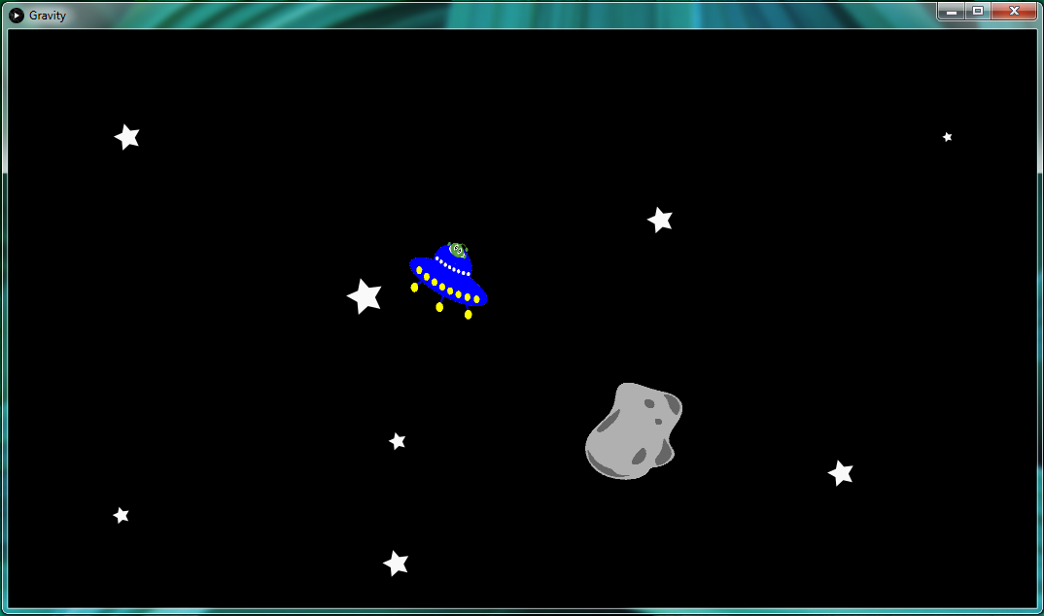

### 2.4.10. System Setup

The system setup needs to define and initialize parameters so that they can be used by both the animation event and the haptic simulation event respectively. In addition to this, system setup also needs to initialize the hardware device (in this example the pantograph mechanism controlled by the Haply control board) so that it can interact with the haptic simulation event.

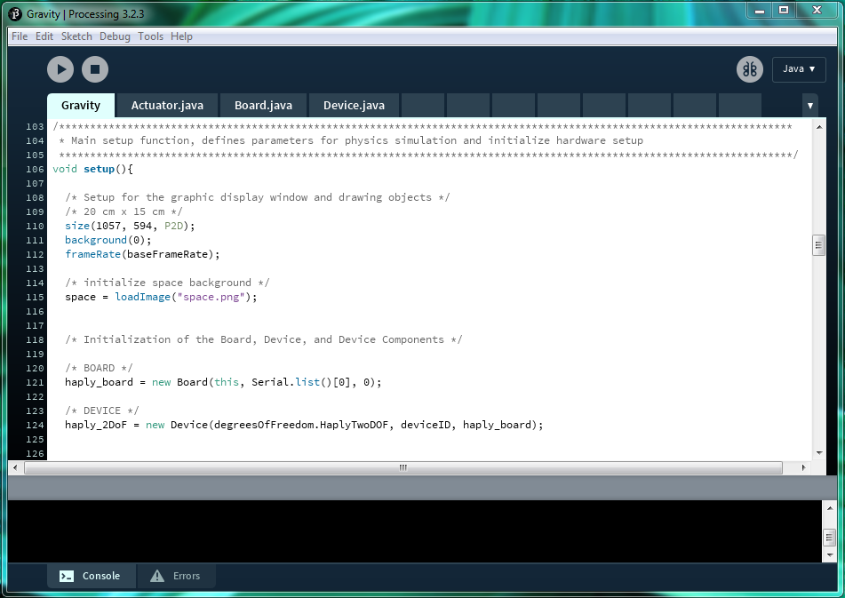

Let us first start by setting up the display window to a desired size and set the frame rate parameter of the animation event. Since we are working in Processing, the animation event are all tasks carried out in the draw() loop.

Next we will initialize the hardware components by creating both a new *haply_board* object and a *haply_2DoF* device object. Within the hAPI, the ***Board*** class creates a ***Board*** object that handles the communication between the control board and the computer that is running the simulation. The control board, in this case the Haply board, is the physical piece of equipment that functions as the interface between our haptic robot and the computer.

Controls for the haptic robot itself is handled by the ***Device*** class creating a ***Device*** object, a virtual representation of the physical device and all the mechanical states. In the same way that a physical device can be broken down into various subcomponents, the physical mechanism of the device, the actuators that move the device, and the sensor that detect changes in state of the device, a ***Device*** object is composed of the ***Mechanism***, ***Actuator***, and ***Sensor*** objects.

Let’s run through the setup in this example starting with the ***Board*** object. In reference to the hAPI documentation, a ***Board*** object has the following constructor prototype:

|  |
| --- |
| **Board**(PApplet app, **String** portName, **int** speed); |

Where:

app - the parent Applet this class runs inside (this is your Processing sketch)

portName - serial port name that the Haply board is connected to (eg, “com10” for windows)

speed - The baud rate of serial data transfer

Since the PApplet parameter is specific to Processing, the main parameters that requires user input would be the portName string and the baud rate state. Now let’s take a look at the setup in this example.

|  |
| --- |
| **haply_board = new Board**(this, **Serial.list()[0]**, **0**); |

The haply_board object is created using a function from the Serial library specifying the string name of the port connection. this parameter can be replaced using the direct string name of the serial port that the Haply board is connected to. An example of such string names across different operating systems are:

windows - “COM10”

Linux - “/dev/ttyUSB0”

Mac - “/dev/tty.usbserial-A6004byf”

In this example, you would note that a baud rate speed of zero was specified, this is not a mistake. Since the Haply control board connects to the computer using the Native Serial USB port, specifying a baud rate speed of zero indicates an unlimited baud rate speed.

After the ***Board*** object has been set up we can now populate the board with some ***Device***’s. We are able to populate the control board with as many devices as we can drive with the actuator outputs. In the case of the Haply Development Board, we can drive up to four independent motors with the hardware that is built into the board, it is possible to drive four 1-degree-of-freedom devices, and two 2-degree-of-freedom devices. In reference to the hAPI documentation, a ***Device*** object has the following constructor prototype:

|  |
| --- |
| **Device**(DeviceType device_type, **byte deviceID**, **Board deviceLink**); |

Where:

device_type - the degrees of freedom type to be implemented

deviceID - ID to be associated with device

deviceLink - Board device is linking to

Now let’s take a look at the setup in this example:

|  |
| --- |
| **haply_2DoF = new Device**(device_type.HaplyTwoDOF, deviceID, haply_board); |

In creating the ***Device*** object, we first dictate the type of device, specifically the degree-of-freedom of the device. In this case, a two-degree-of-freedom is specified using parameters of the Haply pantograph. The needed ***Mechanism***, and the number of ***Actuator***s and ***Sensor***s that compose the haptic robot, which handle s things like the lengths of the links of the robot, the ports that motors are being driven from, and the resolution that the sensors can detect motion, are all automatically generated from this parameter. All these details can be manipulated by the adventurous user, but for most applications, users can stick with the standard mechanism, actuation, and sensing systems. The number of ports that the user defines must match the device type that the user passes to the function.

Next, we assign a unique ID to the device. This parameter lets us differentiate between different multiple haptic robots assigned to the same control board, allowing us to read sensors and control actuators for a specific device.

Finally, we assign which control board the device is attached to. This completes the connect between the haptic robot and the simulation running on the computer by allowing communication over the ports set up when we defined the ***Board*** object.

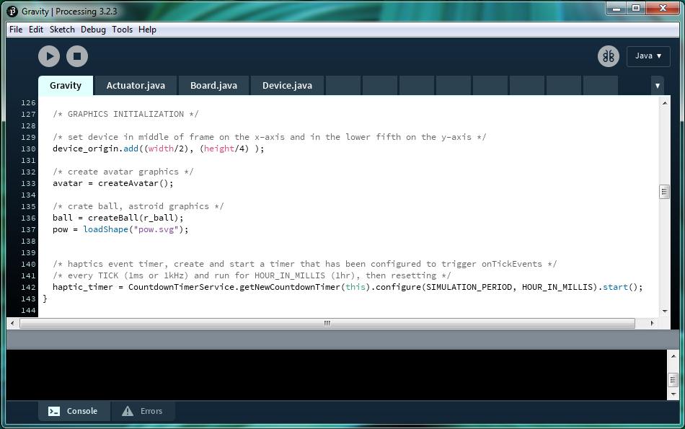

After setting up the graphic display and initializing the hardware, the graphical simulation components can now be initialized. First we set the device to be on the middle of the display frame and in the fifth portion on the vertical axis by adjusting the coordinates of the device origin.

Next we create the graphical representations of each element. In this example, we only need to create the avatar (UFO) controlled by the pantograph device, and the ball (asteroid). A graphic is also initialized here showing a small comic “pow” whenever the UFO and the asteroid collides with one another. Although we use the pantograph mechanism to control the 2D movement of the UFO, only the end-effector position is required, and the pantograph animation does not need to be rendered unlike in previous examples.

### 2.4.11. Animation Event

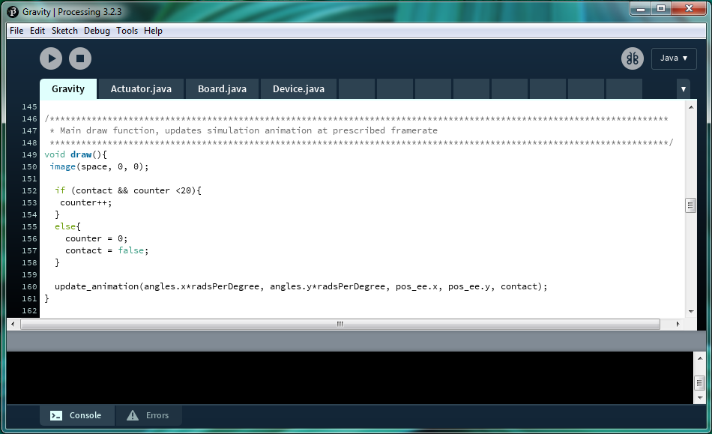

We first refresh the the display with an image rather than a coloured background. Since we are displaying a graphic if the two dynamic animations makes contact within the scene, the logic parameters for determining the event is performed here.

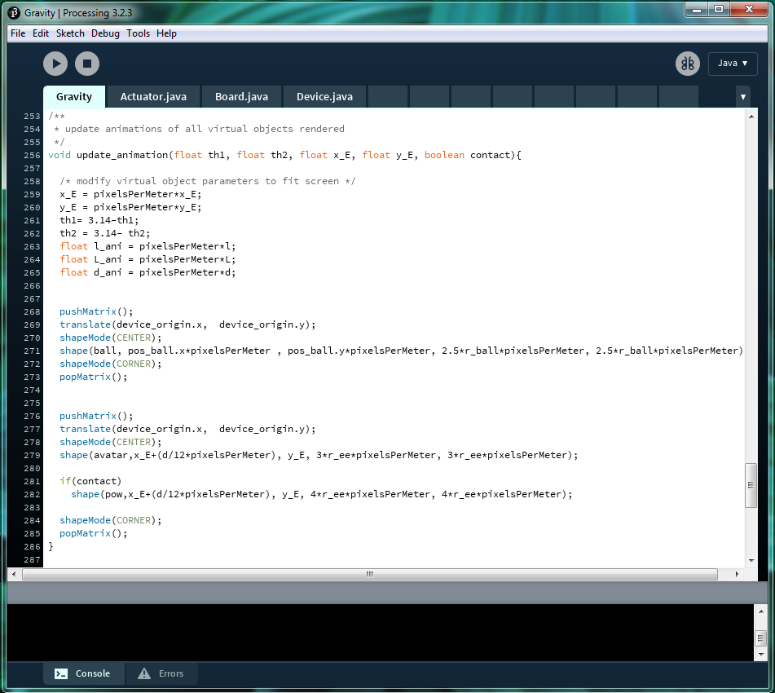

Before determining the parameters of the new animation using the most recent state updates from the simulation, we first need to translate or scale the parameters given to us in terms of SI units to pixels so that they look proportionally appropriate in the display window that was set up. After this is done, all vertices of the graphics associated with the pantograph is updated with the new information.

Next, we update the animation of the ball (astroid) based on positions calculated in the simulations event. the animation for the avatar (UFO) is also updated using the calculated end-effector positions from the simulations event. Based on the interactions between these two active dynamic objects, a “pow” graphic is displayed if the collision conditions are met.

### 2.4.12. Haptic Simulation Event

The haptic simulation events takes angle inputs received from the device hardware and updates the virtual environment accordingly. This event also performs the necessary physics calculations required and finally sends torque renderings to the device hardware.

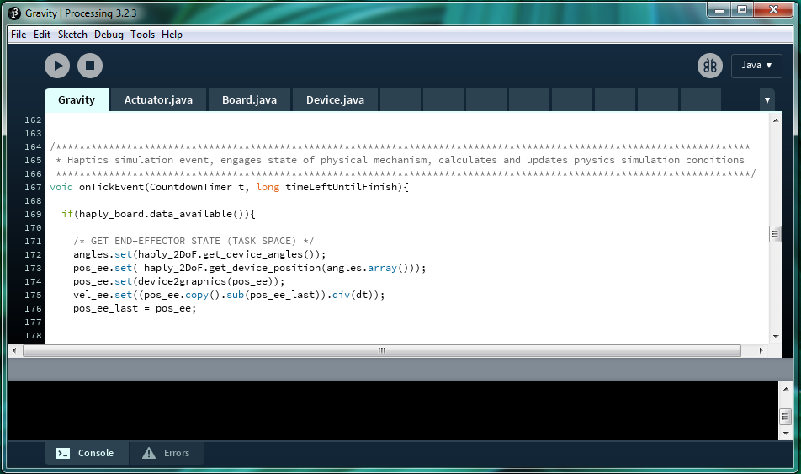

To begin, we first check to see if new angular data is available from the hardware device. If new angle data is available, the angle variables of the device are updated, and the end-effector position and velocity is calculated based on this new data input.

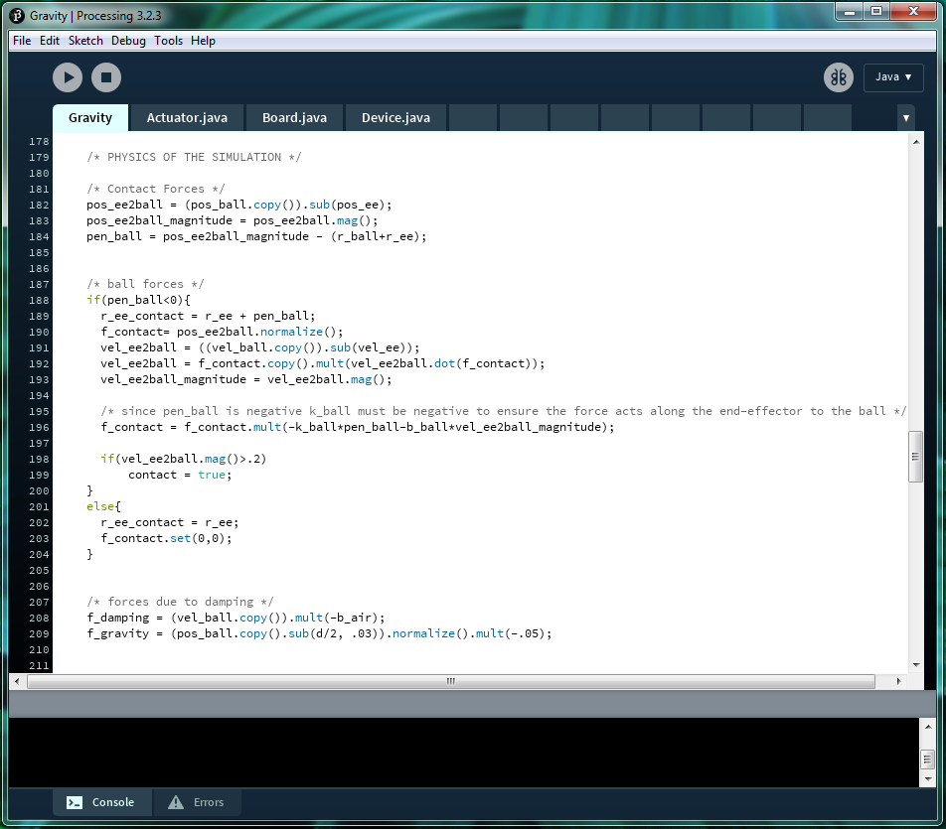

Now we determine the contact force positions by calculating the relative positions of the end-effector (UFO) to the ball (asteroid) and the contact between the ball. If contact was made and there is interaction between the end-effector (UFO) and the ball (asteroid), the contact forces between the two objects are calculated.

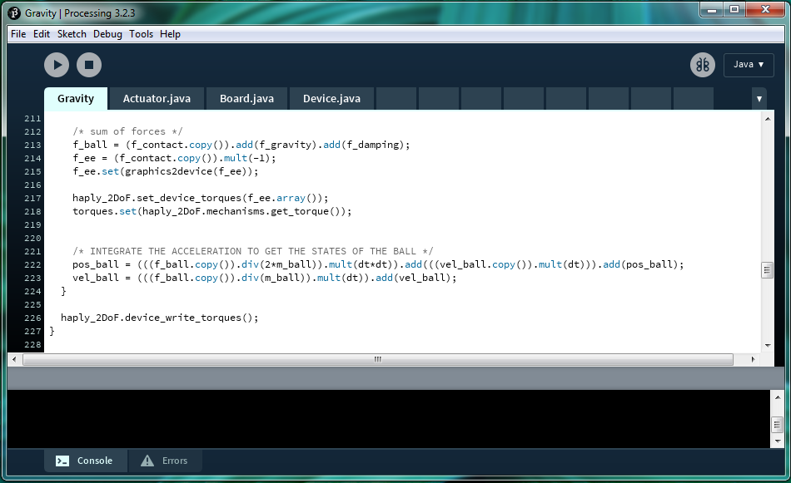

The forces affecting both virtual objects are summed, with an simulated “gravity” force acting on the ball (asteroid) along with any contact force from the end-effector (UFO). The end-effector (UFO) would only experience contact force with the ball (asteroid). Once all the forces have been summed, the calculated torque renderings are sent to the Haply pantograph device.

# 3. HAPI DOCUMENTATION

### 3.0.1. HAPI UML

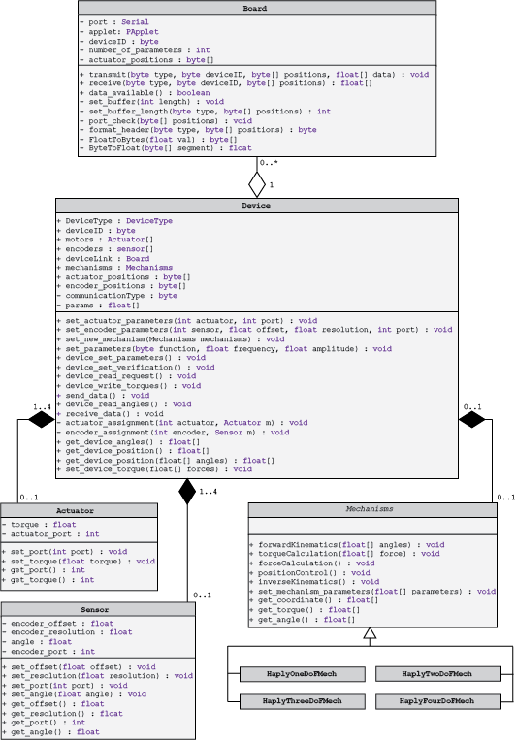

## 3.1. BOARD CLASS

### 3.1.1. Constructor Detail

**Board**

public **Board**(PApplet app, String portName, int speed)

Constructs a Board linking to the specified port at the given serial data speed (baud rate)

**Parameters:**

app - the parent Applet this class runs inside (this is your Processing sketch)

portname - serial port name that the Haply board is connected to (eg, “com10” for windows)

speed - The baud rate of serial data transfer

### 3.1.2. Method Detail

**transmit**

public void **transmit**(byte type, byte deviceID, byte[] positions, float[] data)

Formats and transmits the float data array over the serial port

**Parameters**:

type - type of communication taking place

deviceID - ID of the device transmitting the information

positions - the motor positions the data is meant for

data - main data payload to be transmitted

**receive**

public float[] **receive**(byte type, byte deviceID, byte[] positions)

Receives data from the serial port and formats said data to return a float data array

**Parameters**:

type - type of communication taking place

deviceID - ID of the device receiving the information

positions - the motor positions the data is meant for

**Returns**:

formatted float data array from the received data

**data_available**

public boolean **data_available**()

**Returns**:

a boolean indicating if data is available from the serial port

## 3.2. DEVICE CLASS

### 3.2.1. Constructor Detail

**Device**

public **Device**(DeviceType device_type, byte deviceID, Board deviceLink)

Constructs a Device of the specified DeviceType, with the defined deviceID, connected on specified Board

**Parameters:**

device_type - the degrees of freedom type to be implemented

deviceID - ID to be associated with device

deviceLink - Board device is linking to

### 3.2.2. Method Detail

**set_actuator_parameter**

public void **set_actuator_parameters**(int actuator, int port)

Set the indicated actuator to use the specified motor port

**Parameters**:

actuator - index of actuator that needs parameter to be set or updated

port - specific motor port to be used (motor ports 1-4 on the Haply board)

**set_encoder_parameters**

public void **set_encoder_parameters**(int sensor, float offset, float resolution, int port)

Set the indicated sensor to use the initial offset, resolution, on the specified motor port

**Parameters**:

sensor - index of sensor that needs parameters to be set or updated

offset - initial offset in degrees that the encoder sensor should be initialized at

resolution - step resolution of the encoder sensor

port - specific motor port the encoder sensor is using

**set_new_mechanisms**

public void **set_new_mechanism**(Mechanisms mechanisms)

Replaces the current Mechanisms that is being used with the specified Mechanisms

**Parameters**:

mechanisms - new Mechanisms to replace initialized or old Mechanisms currently in use

**set_parameters**

public void **set_parameters**(byte function, float frequency, float amplitude)

Sets or updates device function parameter and loads frequency and amplitude values into params[] (note* Hapkit specific function)

**Parameters**:

function - device function to be carried out

frequency - frequency variable to be updated

amplitude - amplitude variable to be updated

**device_set_parameter**

public void **device_set_parameters**()

Gathers all encoder sensor setup information of all encoder sensors that are initialized and sequentially formats the data based on specified positions to send over the serial port interface for hardware initialization

**device_read_request**

public void **device_read_request**()

Requests encoder angle data from the hardware based on the initialized setup. device_read_request also sends a torque output command of zero torque for each actuator initialized

**device_write_torque**

public void **device_write_torques**()

Transmits specific torques that has been calculated and stored for each actuator over the serial port interface

**send_data**

public void **send_data**()

Transmits the contents of the params[] array over the serial port interface

**device_read_angles**

public void **device_read_angles**()

receives angle position information from the serial port interface and updates each indexed encoder sensor to their respective received angle

**receive_data**

public void **receive_data**()

receives data from the serial port interface and updates parameters in mechanisms

**get_device_angles**

public float[] **get_device_angles**()

Reads and update angles information from device hardware to encoders

**Returns**:

angles information received from device hardware

**get_device_position**

public float[] **get_device_position**()

Reads and update angles information from device hardware to encoders and performs physics calculations

**Returns**:

end-effector coordinate position

**get_device_position**

public float[] **get_device_position**(float[] angles)

performs physics calculations based on the given angles values

**Parameters**:

angles - angles to be used for physics position calculation

**Returns**:

end-effector coordinate position

**set_device_torque**

public void **set_device_torque**(float[] forces)

Calculates needed output torques based on forces input and updates each initialized actuators respectively

**Parameters**:

forces - forces needed for torque calculations

## 3.3. SENSOR CLASS

### 3.3.1. Constructor Detail

**Sensor**

public **Sensor**()

Constructs a Sensor with motor port position 1

**Sensor**

public **Sensor**(float offset, float resolution, int port)

Constructs a Sensor with the given motor port position, to be initialized with the given angular offset, at the specified step resolution

**Parameters:**

offset - initial angular offset in degrees

resolution - step resolution of encoder sensor

port - motor port position to be used by sensor

### 3.3.2. Method Detail

**set_offset**

public void **set_offset**(float offset)

Sets offset parameter of sensor

**Parameters**:

offset - initial angular offset in degrees

**set_resolution**

public void **set_resolution**(float resolution)

Sets resolution parameter of sensor

**Parameters**:

resolution - step resolution of encoder sensor

**set_port**

public void **set_port**(int port)

Sets motor port position to be used by sensor

**Parameter**:

port - motor port position (motor port connection on Haply board)

**set_angle**

public void **set_angle**(float angle)

Set angle variable to the specified angle

**Parameter**:

angle - angle value

**get_offset**

public float **get_offset**()

**Returns**:

current offset parameter

**get_resoluiton**

public float **get_resolution**()

**Returns**:

current resolution parameter

**get_port**

public int **get_port**()

**Returns**:

current motor port position

**get_angle**

public float **get_angle**()

**Returns**:

current angle information

## 3.4. ACTUATOR CLASS

### 3.4.1. Constructor Detail

**Actuator**

public **Actuator**()

Creates an Actuator with motor port position 1

**Actuator**

public **Actuator**(int port)

Creates an Actuator with the given motor port position

**Parameters:**

port - motor port position for actuator

### 3.4.2. Method Detail

**set_port**

public void **set_port**(int port)

Sets motor port position to be used by Actuator

**Parameter**:

port - motor port position (motor port connection on Haply board)

**set_torque**

public void **set_torque**(float torque)

Sets torque variable to the given torque value

**Parameter**:

torque - new torque value

**get_port**

public int **get_port**()

**Returns**:

current motor port position

**get_torque**

public float **get_torque**()

**Returns**:

current torque information

## 3.5. MECHANISMS CLASS

### 3.5.1. Constructor Detail

**Mechanisms**

Mechanisms is an abstract class designed for use as a template. Current classes which extends the Mechanisms class include:

* HapticPaddle
* HaplyOneDoFMech
* HaplyTwoDoFMech
* HaplyThreeDoFMech

Each class which extends the Mechanisms class will need to follow the abstract methods detailed

### 3.5.2. Method Detail

**forwardKinematics**

public abstract void **forwardKinematics**(float[] angles)

Performs the forward kinematics physics calculation of a specific physical mechanism

**Parameters**:

angles - angle inputs of physical mechanism (length based on degree of freedom)

**torqueCalculation**

public abstract void **torqueCalculation**(float[] force)

Performs torque calculations that actuators need to output

**Parameters**:

force - force values calculated from physics simulation

**forceCalculation**

public abstract void **forceCalculation**()

Performs force calculations

**positionControl**

public abstract void **positionControl**()

Performs calculations for position control

**inverseKinematics**

public abstract void **inverseKinematics**()

performs inverse kinematics calculations

**set_mechanism_parameters**

public abstract void **set_mechanism_parameters**(float[] parameters)

initializes or changes mechanisms parameters

**Parameters**:

parameters - parameter in mechanisms

**get_coordinate**

public abstract float[] **get_coordinate**()

**Returns**:

end-effector coordinate position

**get_torque**

public abstract float[] **get_torque**()

**Returns**:

torque values from physics calculations

**get_angle**

public abstract float[] **get_angle**()

**Returns**:

angle values from physics calculations

# 4. Appendix

## 4.1. Converting between screen size and SI units

In order to have accurate scaling between the forces we render and the dimensions we see displayed on screen we can convert between the graphical environment and SI physical world dimensions.

First we should find our screen resolution. In Windows you can right click on the Desktop and get to the display settings and then navigate to the Advanced display settings.

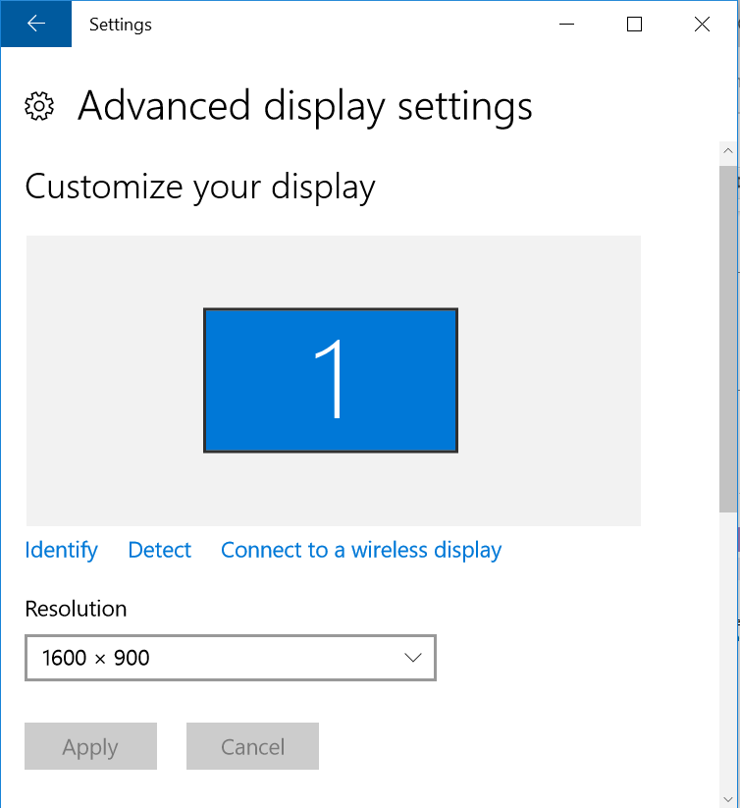

Using the resolution we can determine the number of pixels per meter by dividing the number of pixels by the size of the screen in that dimension. I measured my screen and found that it is 40 cm wide, or 0.4 m. Processing draws the graphics according to the number of pixels on screen so we want to convert the size of the objects we’re rendering into pixels. To do this we simply find the scaling factor of the number of pixels per meter. This is simply the 1600 pixel width divided by the 0.4 m screen width, or 4000 pixels per meter.

When calculating the physical simulation I leave my units in SI units so that the forces and torques calculated in our virtual environment, more or less, map to the forces and torques we output to the device. When we go to draw the virtual environment graphically we can convert the SI units into their corresponding pixel lengths simply by multiplying them by the pixels per meter ratio.

## 4.2. Basic Contact Rendering in 2D: To Come...